Production Planning and Execution (PP)
This case study explains an integrated production planning and execution process in detail and thus fosters a thorough understanding of each process step and underlying SAP functionality.

Product  S/4HANA 2020  Global Bike  Fiori 3.0  Level  Undergraduate  Graduate  Beginner  Focus  Production Planning and Execution  Authors  Michael Boldau  Bret Wagner  Stefan Weidner  Version  4.1  Last Update  June 2022 | MOTIVATION  The data entry requirements in the production planning exercises (PP 1 through PP 6) were minimized because much of the data already existed in the SAP system. This stored data, known as master data, simplifies the processing of business transactions. Examples for this, are material master data, bills of materials, and routings.  In this case study, we will create consumption values for a finished product to plan and process a complete manufacturing cycle. |  | PREREQUISITES  Before you use this case study, you should be familiar with navigation in the SAP system.  In order to successfully work through this case study, it is not necessary to have finished the PP exercises (PP 1 through PP 6). However, it is recommended.  NOTES  This case study uses the Global Bike data set.  

 | Process Overview
Learning Objective Understand and perform a manufacturing process cycle.  Scenario In order to experience a complete manufacturing process you will take on different roles within the Global Bike Group, e.g., production supervisor, shop floor worker and plant manager. Overall, you will be working in the Materials Management (MM) and the Production Planning and Execution (PP) departments.  Employees involved Jun Lee (Production Manager)  Hiro Abe (Plant Manager)  Lars Iseler (Shop Floor Worker 2)  Susanne Castro (Goods Receipt Clerk)  Sanjay Datar (Warehous Employee)  Michael Brauer (Shop Floor Worker 4)  Jamie Shamblin (Controller) |  | Time 200 min
Before you can start forecasting demand for your touring bike product group, changes in the material master record of the bikes need to be maintained.
Afterwards you will create a 12-month sales and operations plan (SOP) for your product group, receive the production relevant goods from the warehouse storage location and issue them to the production order.
To conclude the process, the production is confirmed as complete, the finished goods are received into the warehouse and costs assigned to the production order are analyzed.

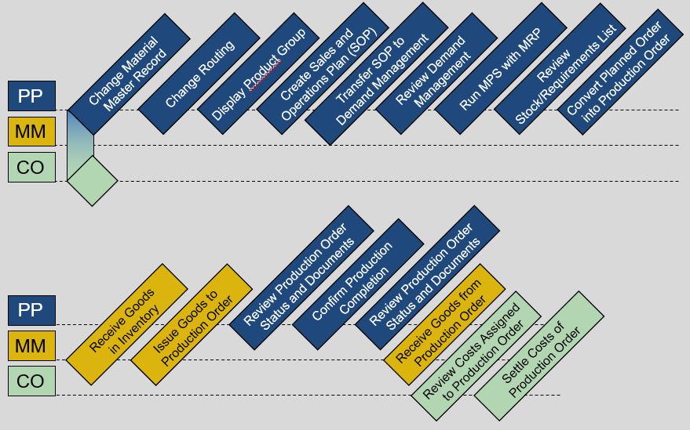
Table of Contents
Process Overview 2
Step 1: Change Material Master Record 5
Step 2: Change Routing 10
Step 3: Display Product Group 14
Step 4: Create Sales and Operations Plan (SOP) 17
Step 5: Transfer SOP to Demand Management 22
Step 6: Review Demand Management 25
Step 7: Run MPS with MRP 27
Step 8: Review Stock/Requirements List 31
Step 9: Convert Planned Order into Production Order 34
Step 10: Receive Goods in Inventory 37
Step 11: Issue Goods to Production Order 41
Step 12: Review Production Order Status 44
Step 13: Confirm Production Completion 48
Step 14: Review Production Order Status 50
Step 15: Receive Goods from Production Order 52
Step 16: Review Costs Assigned to Production Order 54
Step 17: Settle Costs of Production Order 56
PP Challenge 60

 | Step 1: Change Material Master Record
Task Prepare a material master record for Demand Planning.  Short Description In order to plan Global Bike’s deluxe touring bikes (black, silver and red) prepare their material master records by adding planning-relevant data to these records.  Name (Position) Jun Lee (Production Manager) |  | Time 20 min
To change the views of a material, use the Manage Product Master Data app in the Production Planning and Execution area. |  | Manage Product Master Data
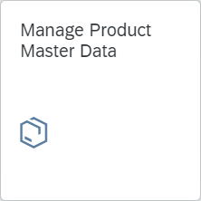
In the search screen, enter DXTR*### (replace ### with your three-digit number) in the search field. |  | DXTR*###
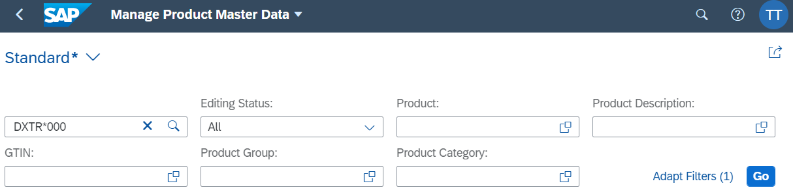
Press . Your various Deluxe Touring Bikes will be displayed.
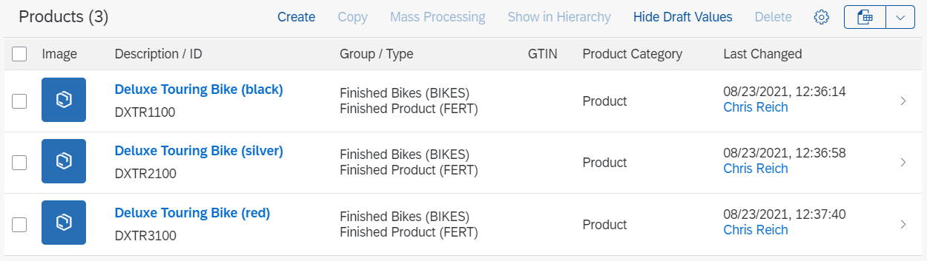
Click the line of Deluxe Touring Bike (red) (DXTR3##) to open the details of the product.
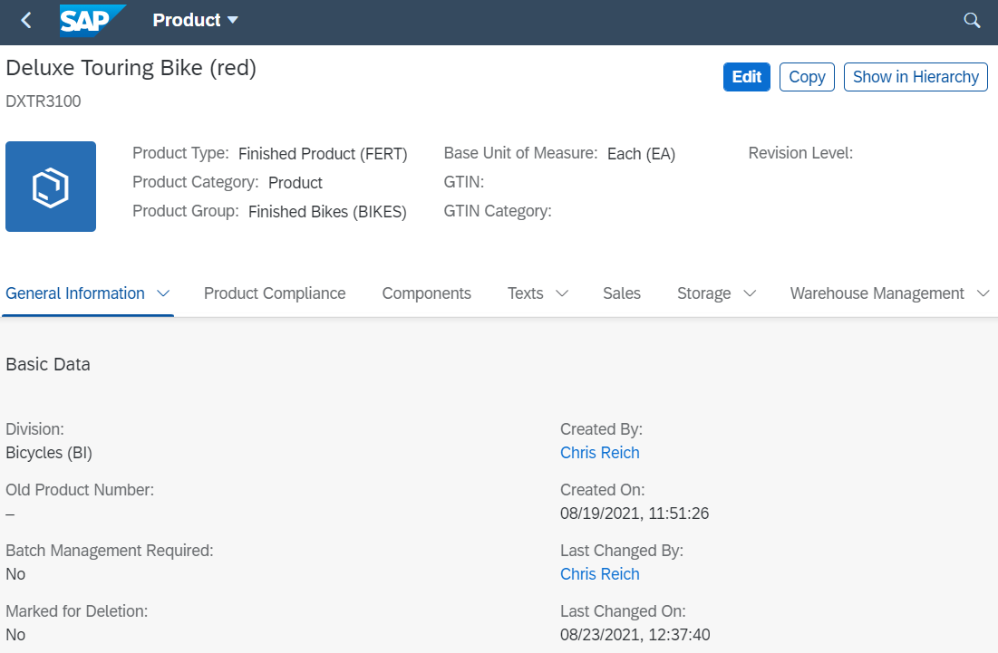
Press  to switch to the edit mode.
Use the pull-down menu to select the Plants section. The window automatically scrolls to the correct position. |  | Plants
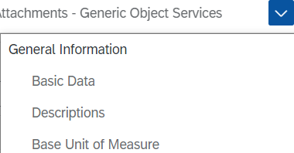
…
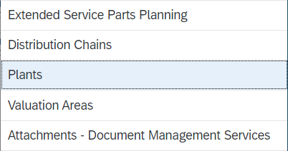
You will see a list of all plants for which the product has been defined.
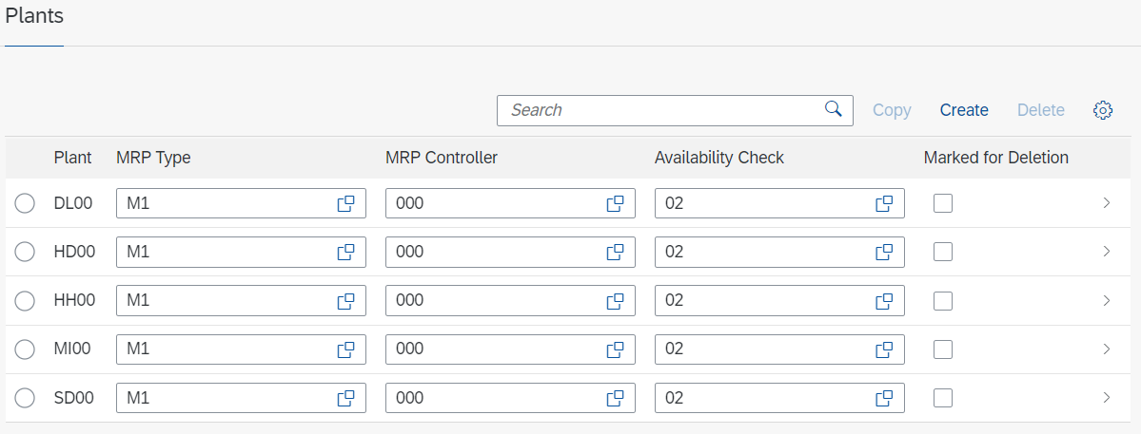
Press at the end of the line with the DL00 plant to open the plant-specific product master data.
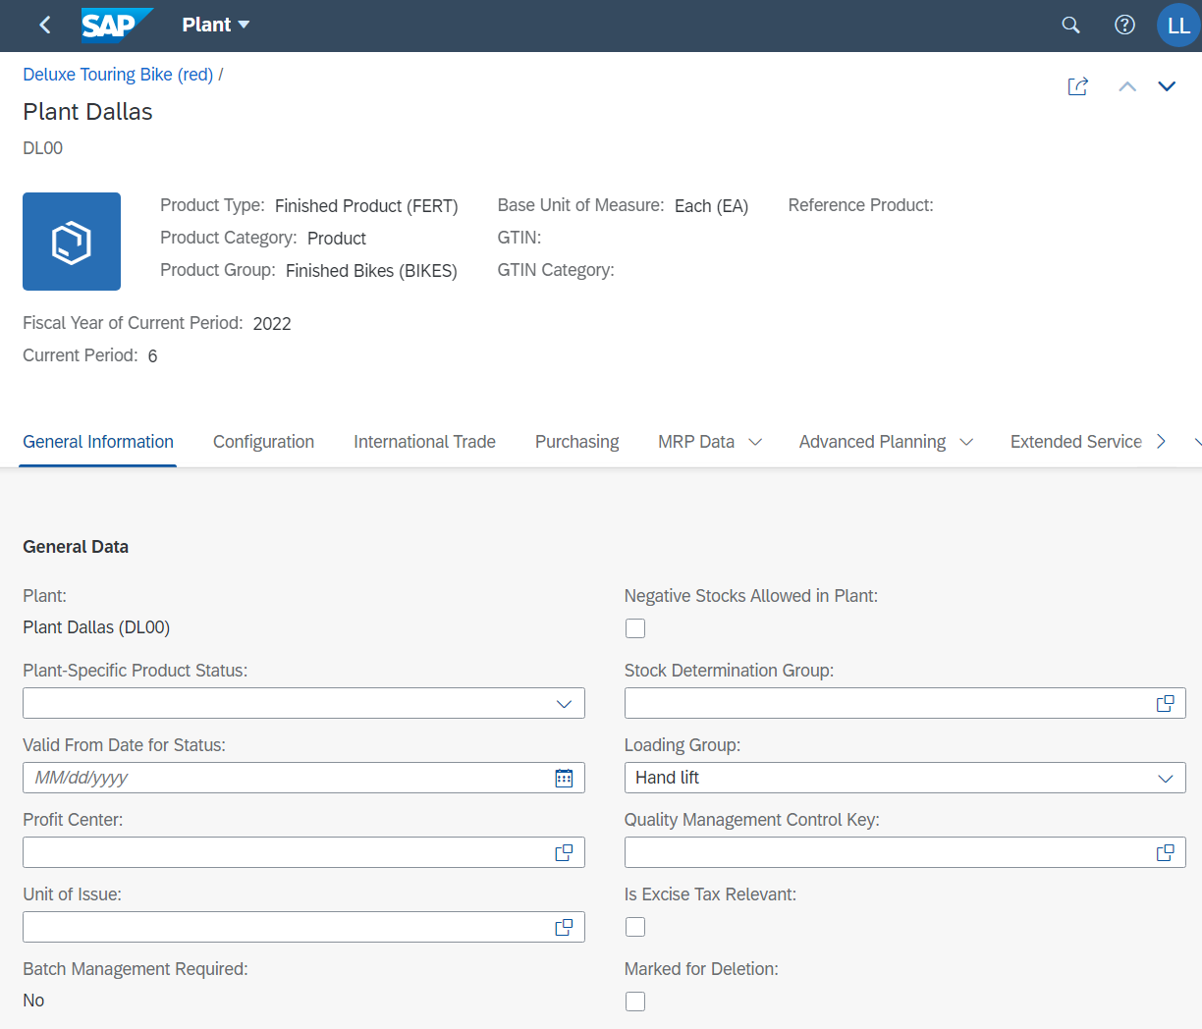
Select the MRP Data area. The window automatically scrolls to the correct position. Enter 40 in the Strategy Group field (Planning with final assembly). |  | MRP Data  40
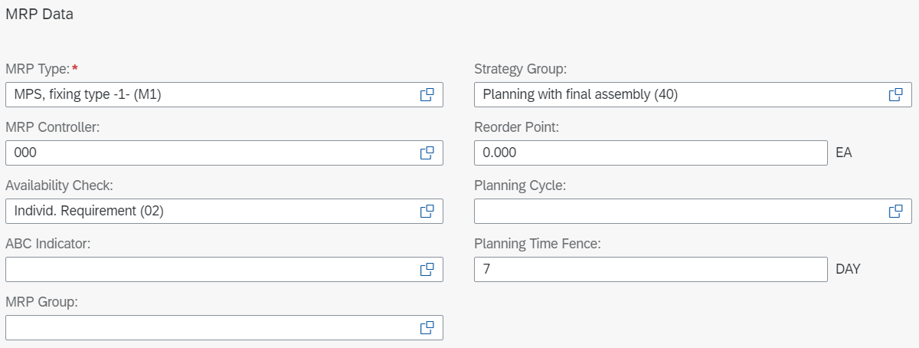
Select the Forecasting ► Required Periods area. If the tab is not visible, you can use the pull-down menu again. |  | Forecasting Required Periods
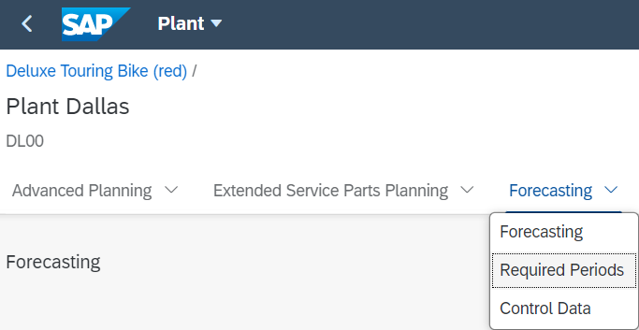
In the Periods for Initialization field enter 12. Scroll down to the next area Control data. |  | 12
In the Control Data area below, click on the value help icon of the Optimization Level field and select the optimization level F - Fine (high optimization level). Then select Parameter Optimization. |  | F  Parameter Optimization
Now assign the smoothing factors. Enter 0.20 for the Alpha Factor (base value), 0.10 for the Beta Factor (trend value), 0.30 for the Gamma Factor (seasonal index) and 0.30 for the Delta Factor (MAD). |  | 0,20  0,10  0,30  0,30
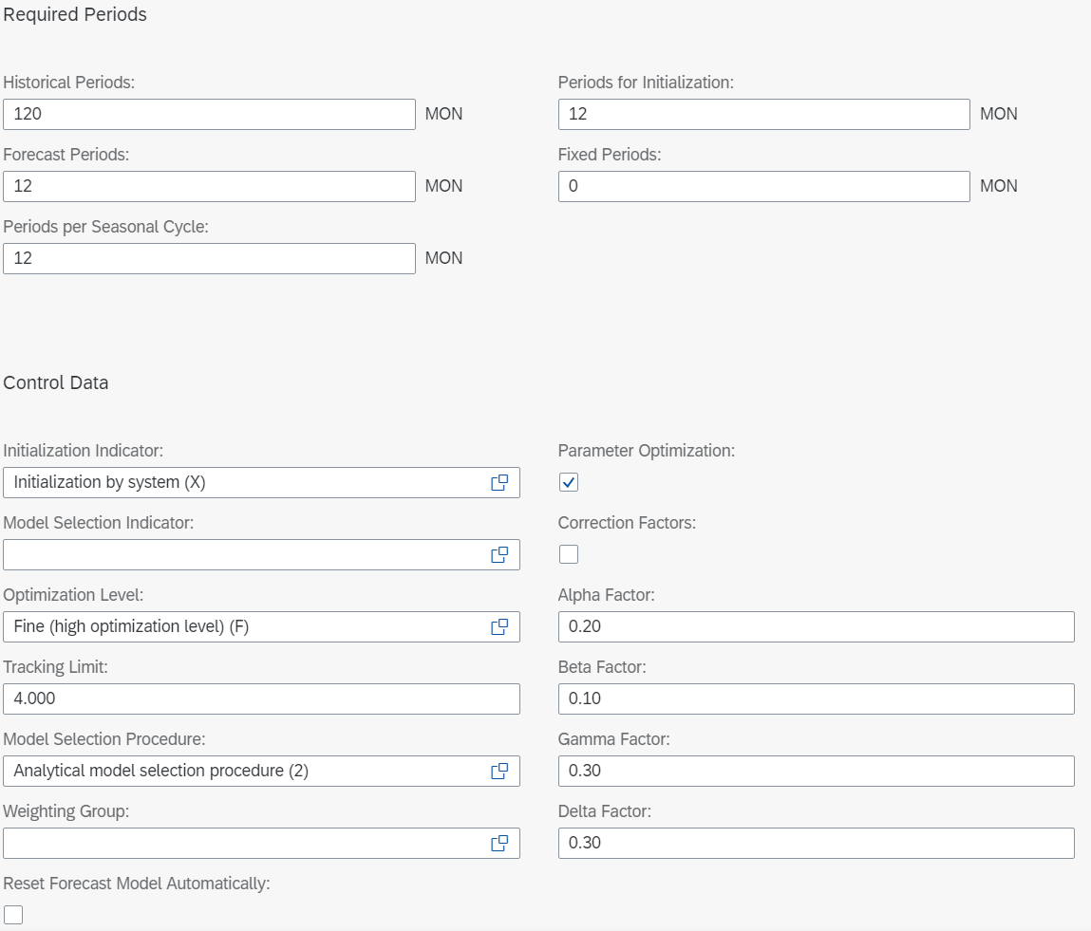
Select to save the plant-specific data for plant DL00.
Click  to save your changes to the red Deluxe Touring Bike.
The SAP system updates the master data record for material DXTR3### and displays a corresponding message.
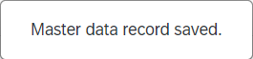
Select 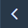 to return to the Manage Product Master Data screen.
Repeat the same procedure for the silver and black Deluxe Touring Bike. Start with the silver one (DXTR2###) and then change the black bike (DXTR1###). |  | DXTR2###  DXTR1###
Click to return to the SAP Fiori Launchpad.

 | Step 2: Change Routing
Task Change a routing for a finished good.  Short Description Change the routing for your red Deluxe Touring bike.  Name (Position) Jun Lee (Production Manager) |  | Time 15 min
After the operational steps are laid out, the components must be allocated to the individual operations. This is a progressive process where each operation builds off the materials that entered production in the previous operations.
To change the routing, use the Change Routing app in the Production Planning and Execution area. |  | Change Routing
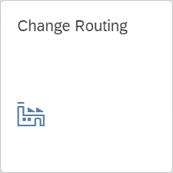
Enter the material number of your red Deluxe Touring bike (DXTR3###). In the Plant field, enter the Global Bike plant number in Dallas (DL00). |  | DXTR3###  DL00
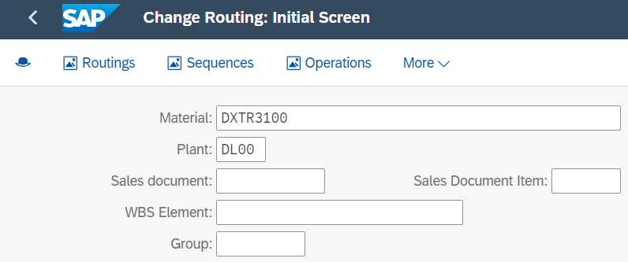
Also make sure that the Planner Group field is empty. Then press .
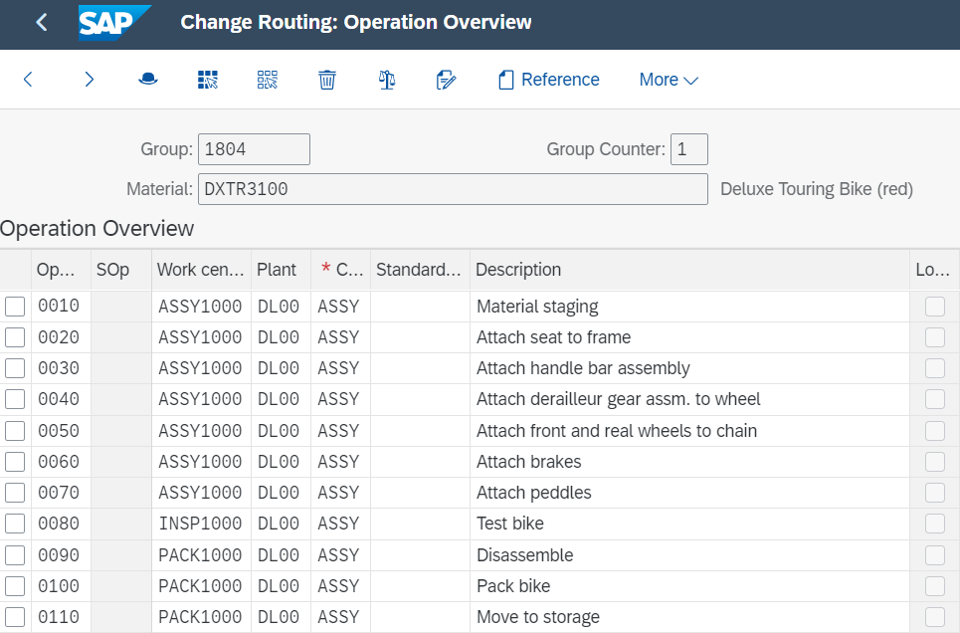
Note A routing is defined by the routing group and the routing group counter. Moreover, the routing contains a reference to the material whose production is described by the routing.

Besides the standard sequence, it can also have parallel or alternative sequences. Alongside the standard values, the routing also contains time elements that are relevant for scheduling operations. Each operation in the routing may contain its own base quantity, to which these time elements may refer.
Select 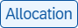 to display a list of all components. If this is not displayed, you will find the entry in the pull-down menu under More ► Allocation.
Select the rows Touring Frame-Red (TRFR3##) and Touring Seat Kit (TRSK1##). |  | TRFR3###  TRSK1###
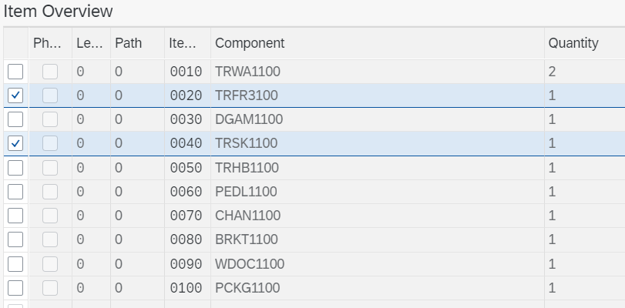
Press . In the popup that appears, enter 0020 for Activity and confirm the entry with . |  | 0020
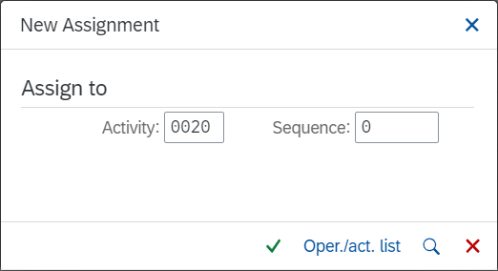
Back in the Material Component Overview you can see that both components have now been assigned to Activity 0020.
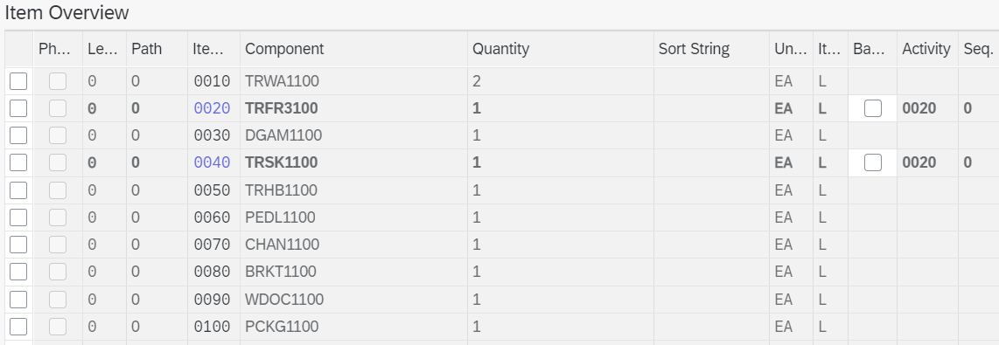
Repeat this process for all other components and assign them to the operations below. |  | TRHB1### - 0030  TRWA1### - 0040  DGAM1### - 0040  CHAN1### - 0050  BRKT1### - 0060  PEDL1### - 0070  WDOC1### - 0100  PCKG1### - 0100
  Component | Operation
  TRHB1### (touring handlebar) | 0030
  TRWA1### (touring aluminum wheel assembly) | 0040
  DGAM1### (derailleur gear assembly) | 0040
  CHAN1### (chain) | 0050
  BRKT1### (brake kit) | 0060
  PEDL1### (pedal assembly) | 0070
  WDOC1### (warranty document) | 0100
  PCKG1### (packaging) | 0100
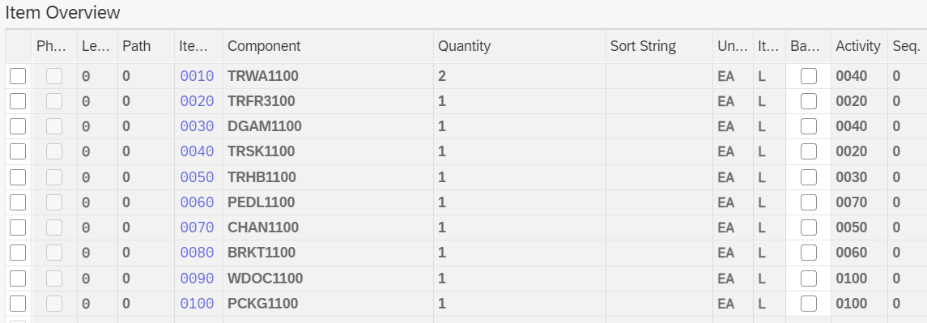
Apply your changes with . The system issues a message that the routing has been saved.
Click to return to the SAP Fiori Launchpad.

 | Step 3: Display Product Group
Task Display a product group.  Short Description Display the product group (product family) for all your Deluxe Touring bikes.  Name (Position) Jun Lee (Production Manager) |  | Time 5 min
A product group (product family) supports high-level planning. This way, it is not necessary to delve into the minutia of creating planning forecasts for every material in the company. |  | Product group
To view the Deluxe Touring bike product group, use the Display Product Group app in the Production Planning and Execution area. |  | Display Product Group
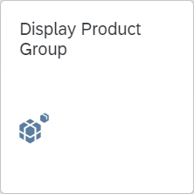
In the Display Product Group: Initial Screen, in the Product group field find and select your group for deluxe touring bikes. In order to do so, press the search icon (or pressed F4), enter ###* in the Material description field. Remember to replace ### with your three-digit number, e.g., enter 009* if your number is 009. Enter DL00 as Plant. |  | ###*  DL00
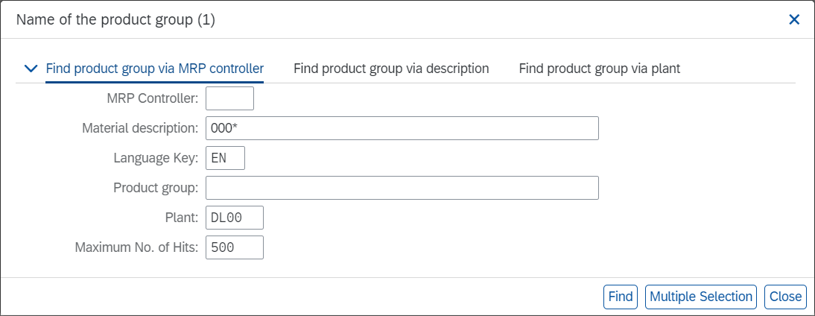
Then, press Enter or click on  to display the search results.
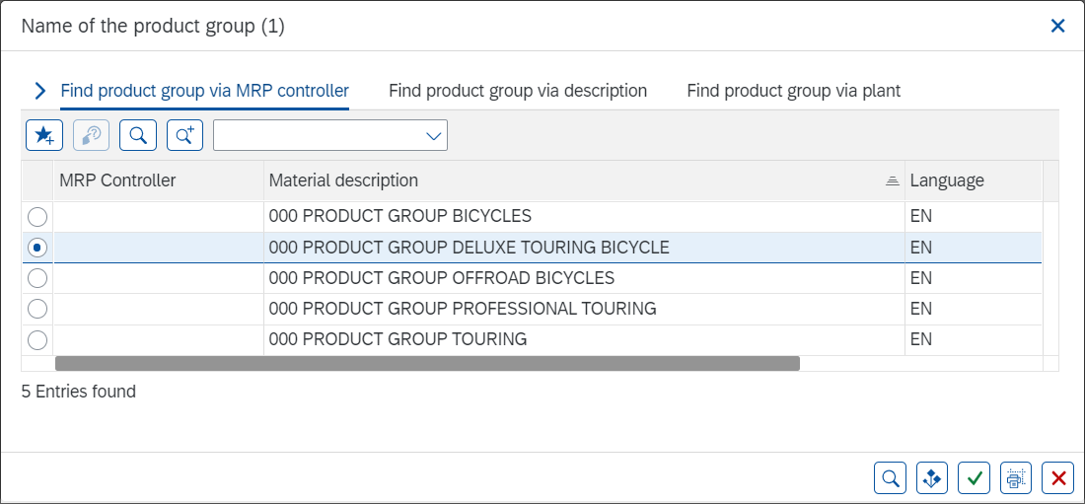
You will see a list of all your product groups, e.g., for mountain bikes or touring bikes. Select the group of Deluxe Touring Bikes (PG-DXTR##). Then click to apply the selection. |  | PG-DXTR###
Now that the correct Product group (PG-DXTR###) is filled in, make sure that Plant DL00 is entered. |  | DL00
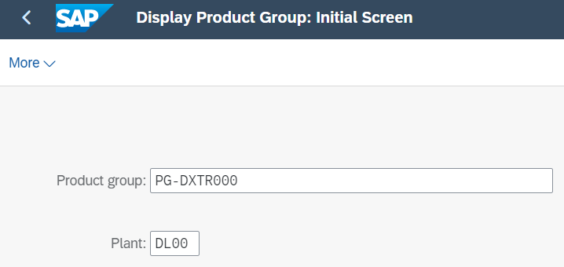
Then, press Enter to display the product group details.
On this screen, you can see that this product group defines proportions for three different bikes: the black, silver and red deluxe touring bike. For the black bike, a share of 40% will be considered and 30% for the silver and the red bikes each.
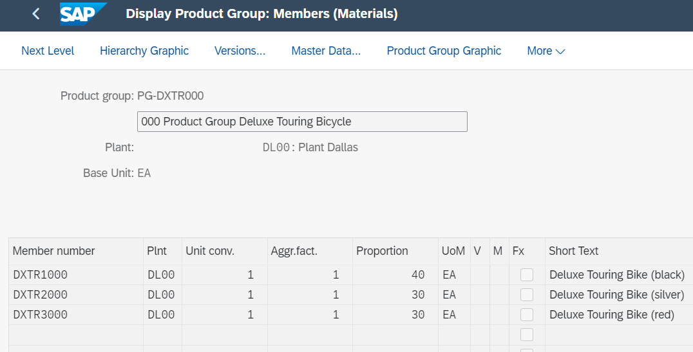
Click to return to the SAP Fiori Launchpad.

 | Step 4: Create Sales and Operations Plan (SOP)
Task Create a sales and operations plan for a product group.  Short Description Create a 12-month sales and operations plan (SOP) for your product group.  Name (Position) Jun Lee (Production Manager) |  | Time 20 min
A sales and operations plan (SOP) is a planning tool that is used to consolidate data for forecasting future sales and production levels as well as the methods needed to meet those requirements. In this task, our SOP will be based on historical consumption values taken from a fixed period. This is in contrast to forecasting within a real-life system which would base the prediction on previous periods and their respective consumption. |  | Sales and operations plan
To create an SOP, use the Create Sales and Operations Plan app in the Production Planning and Execution area. |  | Create Sales and Operations Plan
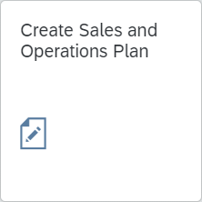
Make sure that Product group PG-DXTR### and Plant DL00 are entered. Then, select . |  | PG-DXTR###  DL00
Record the version number: __
In the menu bar, select:
More ► Edit ► Create sales plan ► Forecast…
Select Period intervals, Forecast from current period/current year to previous period/next year, Historic Data from 06/2017 to 03/2021, Forecast execution Aut. model selection. Compare your screen with the one below before clicking on  to view the historical values. |  | Period intervals  current period/current year  previous period/next year  04/2017  03/2021  Aut. model selection
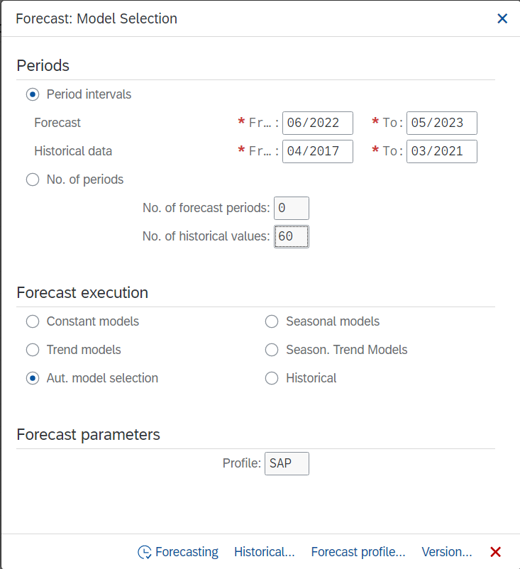
You will get an overview of the passed periods in the specified time range.
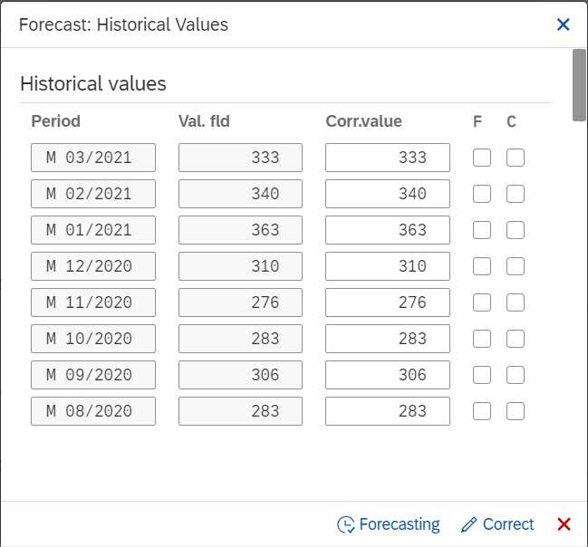
Click on .
In the next Popup the system selected Trend and season. Click on again.
In the next pop-up you can see that the system tested and found Seasonal and Trend tendencies in the past consumption data and has applied a Seasonal Trend Model.
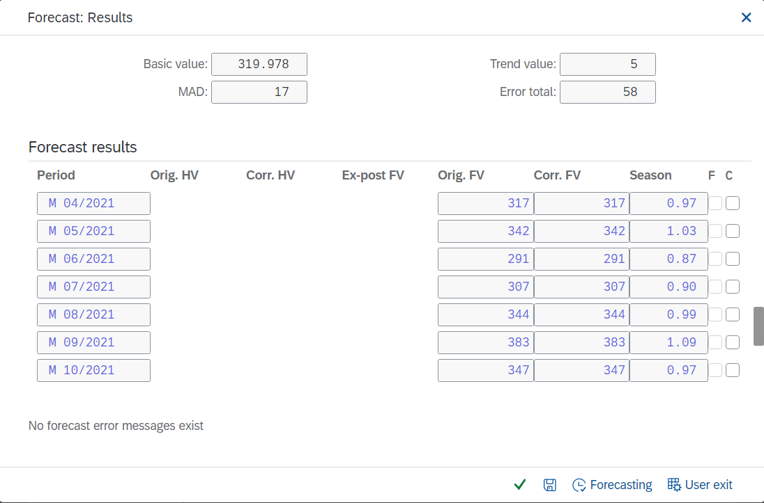
Press , the sales forecast has been transferred to the SOP.
Look at the planning table. Note that your values may differ from the screenshot.
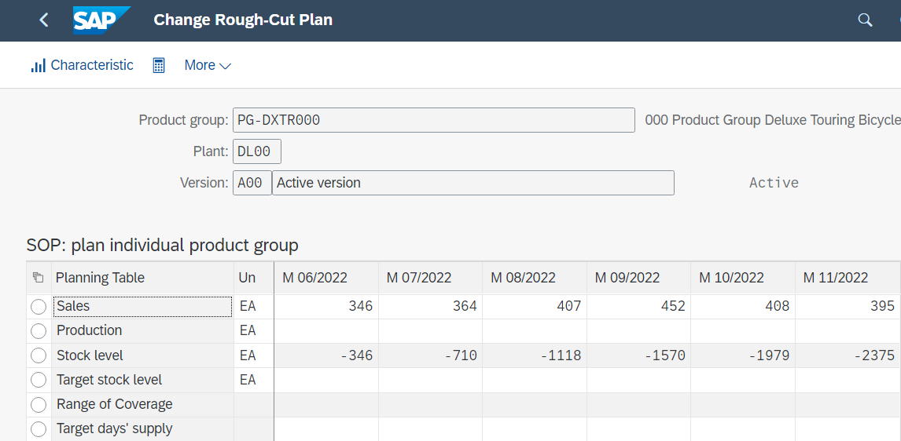
As Target day’s supply enter 5 for each forecasted period. |  | 5
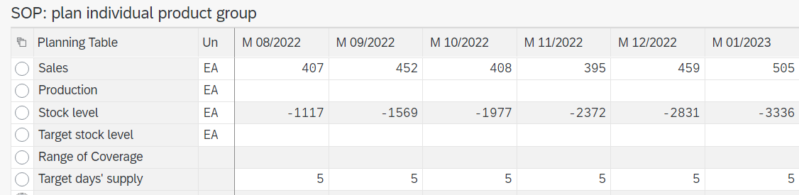
In a production plan, you plan the quantities you need to produce in order to meet your sales plan. The system then calculates stock levels and days’ supply for each period on the basis of the sales and production quantities and any target data. There are several different planning strategies available, which differ in the production values and the stock levels proposed.
As the SOP is a high-level planning, discrete production values are not necessary. The SAP system calculates discrete numbers once the SOP is transferred to the Demand Management.
In the menu bar, select:
More ► Edit ► Create production plan ► Synchronous to sales
Note the change in the Production and in the Stock level rows. The production plan is created to match the sales forecast.
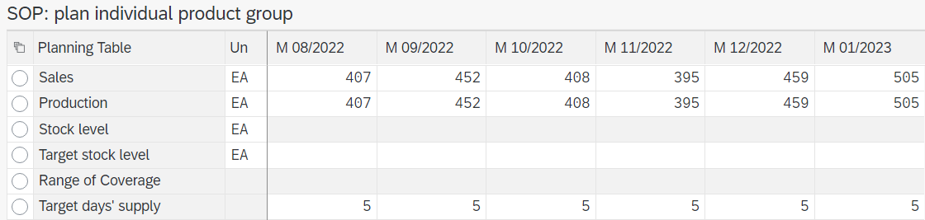
In the system menu, select
More ► Edit ► Create production plan ► Target day’s supply
Note the impact on the production plan and stock levels. Production levels are generated to match the sales plus the amount needed to be put into stock to meet the target days’ supply specifications.
Review the Planning Table (your numbers may be different).
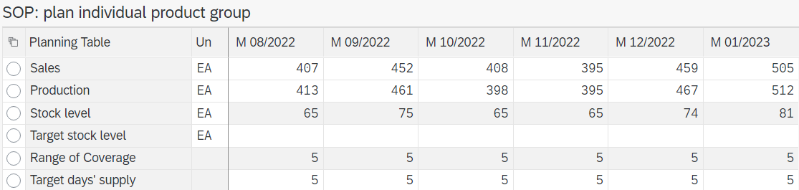
Note Although the screen displays integer production values, the SAP system calculates with decimal precision. You can display the decimal places of a series by pressing F8. Then create the production plan.
Accept the SOP with . A system message appears and you return to the initial screen.
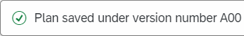
Click to return to the SAP Fiori Launchpad.

 | Step 5: Transfer SOP to Demand Management
Task Transfer SOP to Demand Management.  Short Description Transfer the Sales and Operations Plan to Demand Management.  Name (Position) Jun Lee (Production Manager) |  | Time 10 min
Demand Management is the tool used to disaggregate planning data from high-level plans down to the detailed planning level. For this task, planning for the Deluxe Touring Product Group will be broken down into the individual components that belong to this group. |  | Demand Management
To transfer sales/rough planning to Demand Management, use the Transfer Planning Data to Demand Management app in Production Planning and Execution area. |  | Transfer Planning Data to Demand Management
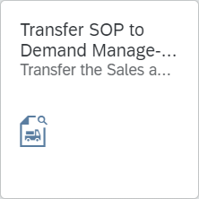
Enter Product group PG-DXTR###, Plant DL00, and the version saved in the previous task (A00). |  | PG-DXTR###  DL00  A00
Select Prod.plan for mat. or PG members as proportion of PG and Active. Then, deselect the Invisible transfer indicator to present the disaggregation results on another screen allowing the planner to modify the results before saving them manually to Demand Management. |  | Prod.plan for mat. or PG members as prop. of PG  Active  Invisible transfer
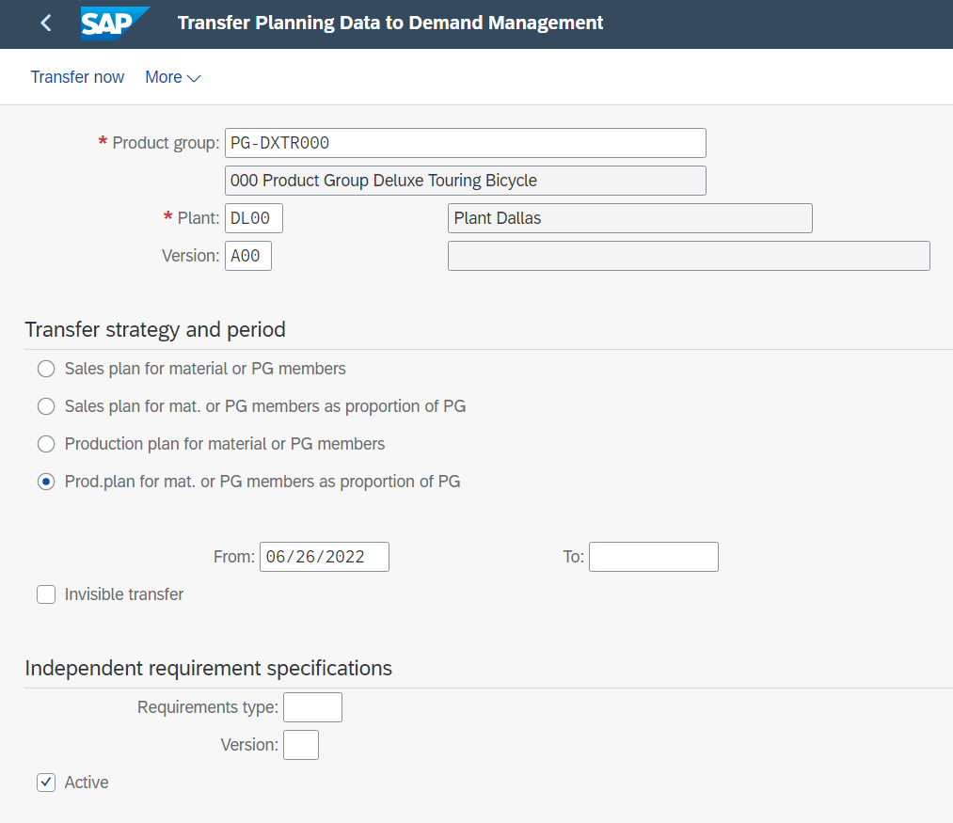
Select and examine the Planned Independent Requirements generated for DXTR1###.
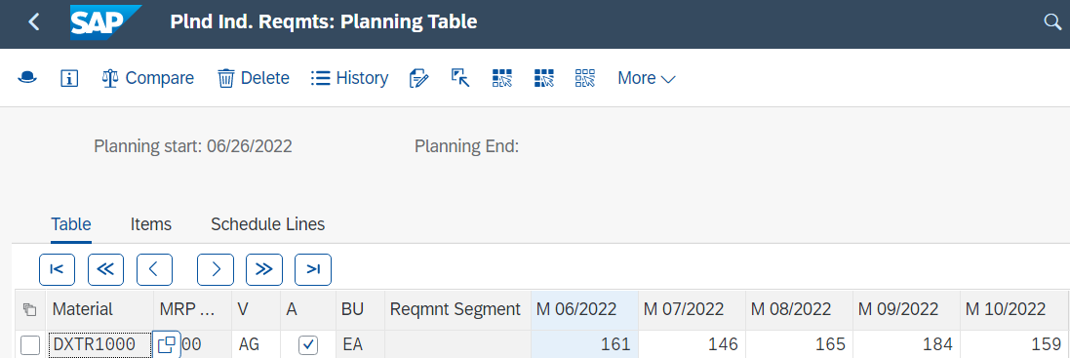
Then click on to save the demand for the DXTR1###.
After saving, the system jumps to the independent requirement of the next material (DXTR2###). Now examine the independent requirement generated for DXTR2###.
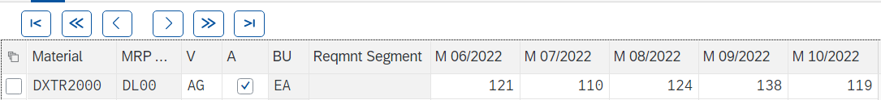
Continue with . Finally, examine the planned independent requirement of material DXTR3###.
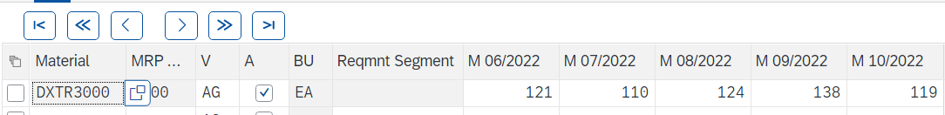
Also save this requirement with .
Note DXTR1### makes up 40%, DXTR2### makes up 30% and DXTR3### another 30% of the production plan created in your Sales and Operations Plan.
You will automatically return to the initial screen. The system also provides you with a message that the requirement has been saved. You can also see this in the other materials in advance.
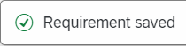
Click to return to the SAP Fiori Launchpad.

 | Step 6: Review Demand Management
Task Review the requirements for a product group.  Short Description Review the requirements for the product group to ensure that there are production requirements for the individual production items.  Name (Position) Hiro Abe (Plant Manager) |  | Time 10 min
To view planned requirements, use the Maintain PIRs app in Production Planning and Execution area. |  |  | Maintain PIRs
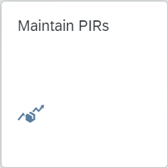
A welcome message is displayed informing you that you do not yet belong to any area of responsibility. Confirm this with . You will be forwarded automatically.
The My Area of Responsibility screen appears with a list of existing plants. Set your responsibility for the plant DL00. |  |  | DL00
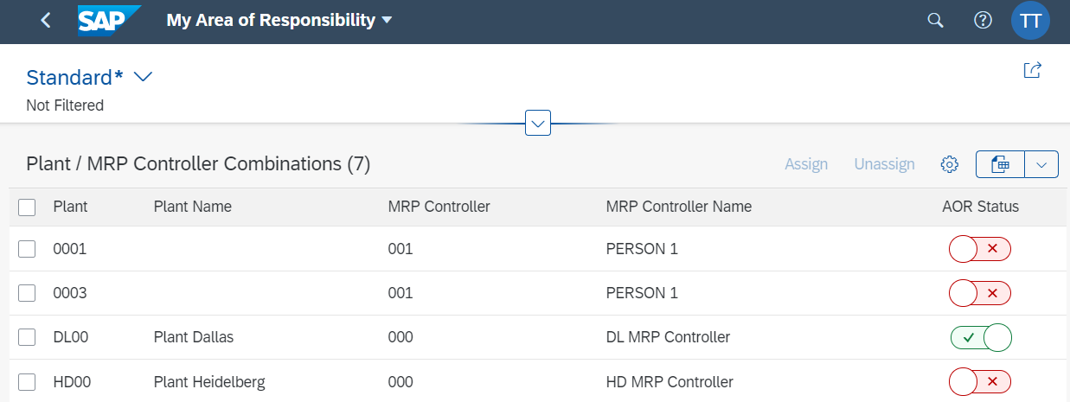
Then click to return. In the Maintain PIRs screen expand the search by pressing .
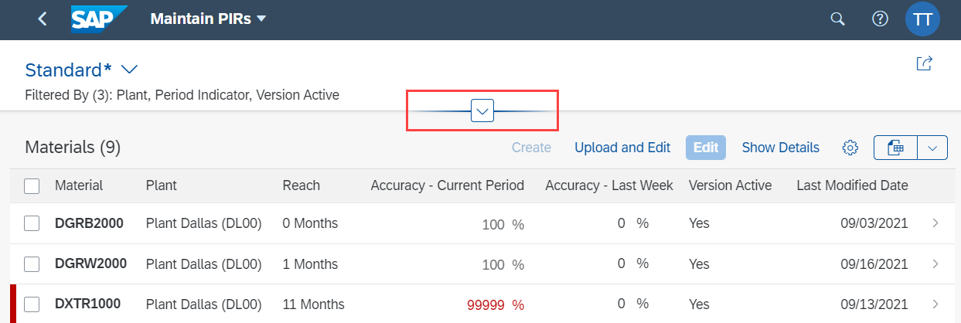
The plant in Dallas (DL00) is already preselected. Now enter DXTR*### as the search term and change the Version Active field to No and select Yes. |  |  | DXTR*###  no  yes
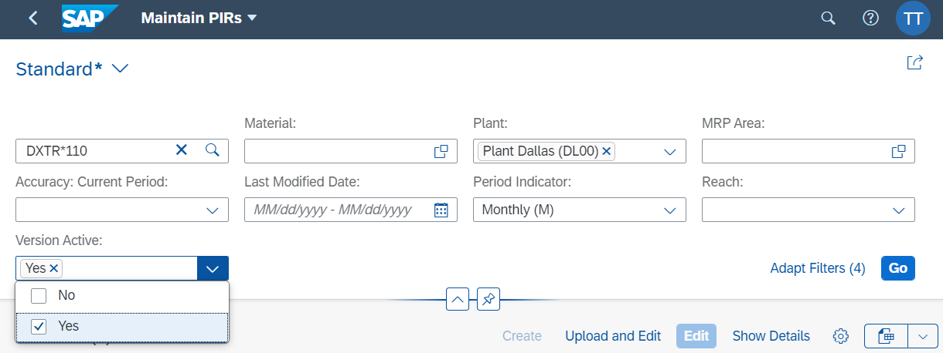
Press to run the search with the new criteria. You will now be shown your three Deluxe Touring Bikes.
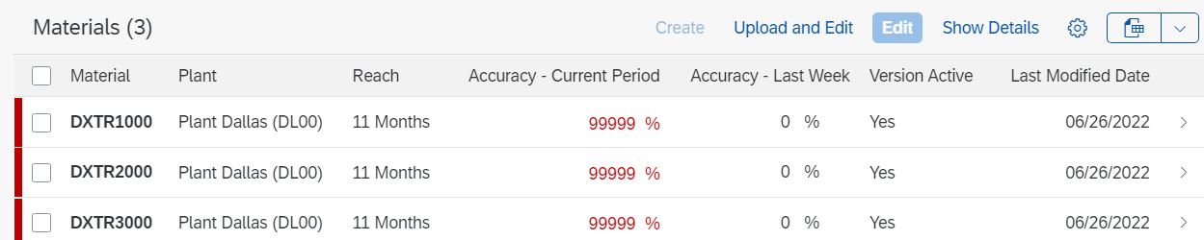
Select all three lines and click .
View planned independent demands for the Deluxe Touring Bike product group for all 3 materials.
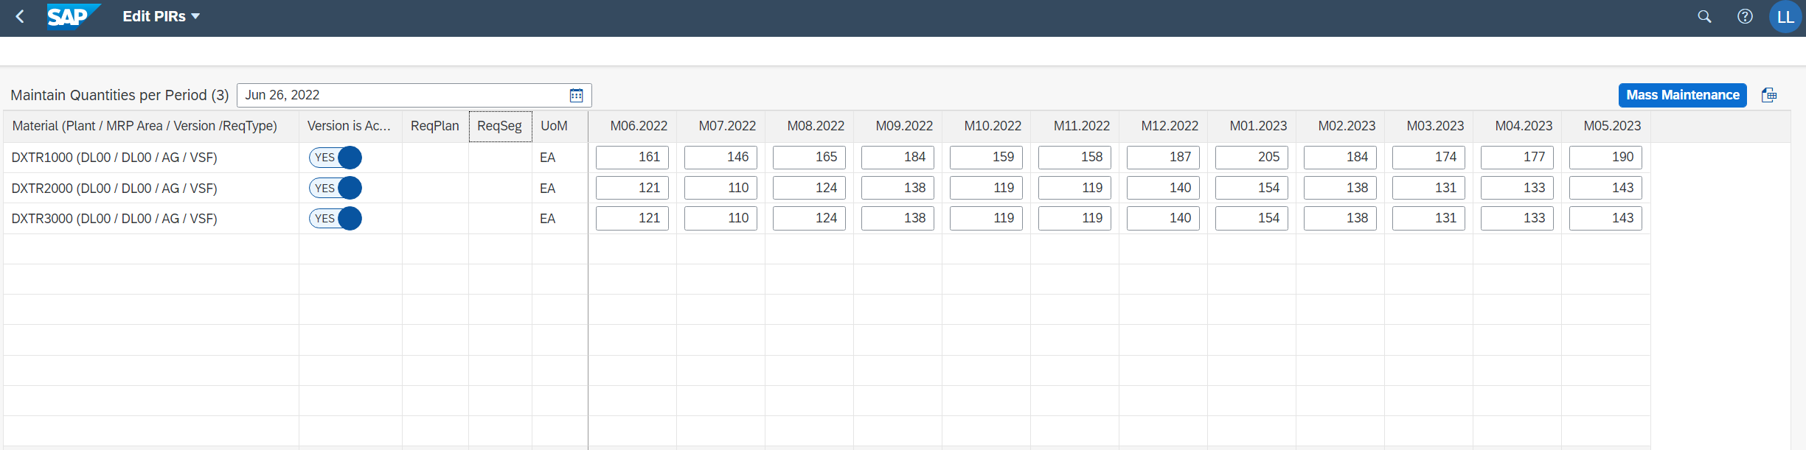
Click to return to the SAP Fiori Launchpad.

 | Step 7: Run MPS with MRP
Task Run Master Production Scheduling (MPS).  Short Description Run Master Production Scheduling (MPS) to generate a series of planned orders that satisfy the requirements from SOP and demand management. Concurrently with MPS, the MRP materials will be processed leading to the generation of planned orders for dependent requirements that have been created by the BOM explosion process.  Name (Position) Jun Lee (Production Manager) |  | Time 10 min
To start Master Production Scheduling, use the Schedule MRP Run - Run MPS with MRP app in the Production Planning and Execution area. |  | Schedule MRP Run
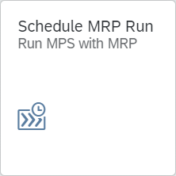
Enter your Material DXTR3###, and as Plant DL00.  The control parameters can be adopted and should be filled in by the system as follows:  - Processing Key: NETCH (Net-Change in Total Horizon)  - Create Purchase Req.: 2 (Purchase requisition in opening period)  - SA Deliv. Sched. Lines: 3 (Schedule lines)  - Create MRP List: 1 (MRP list)  - Planning mode: 1 (Adapt planning data (normal mode))  - Scheduling: 1 (Determination of Basic Date for Planned)  Then, select Display material list. |  | DXTR3###  DL00  NETCH  2  3  1  1  1  Display material list
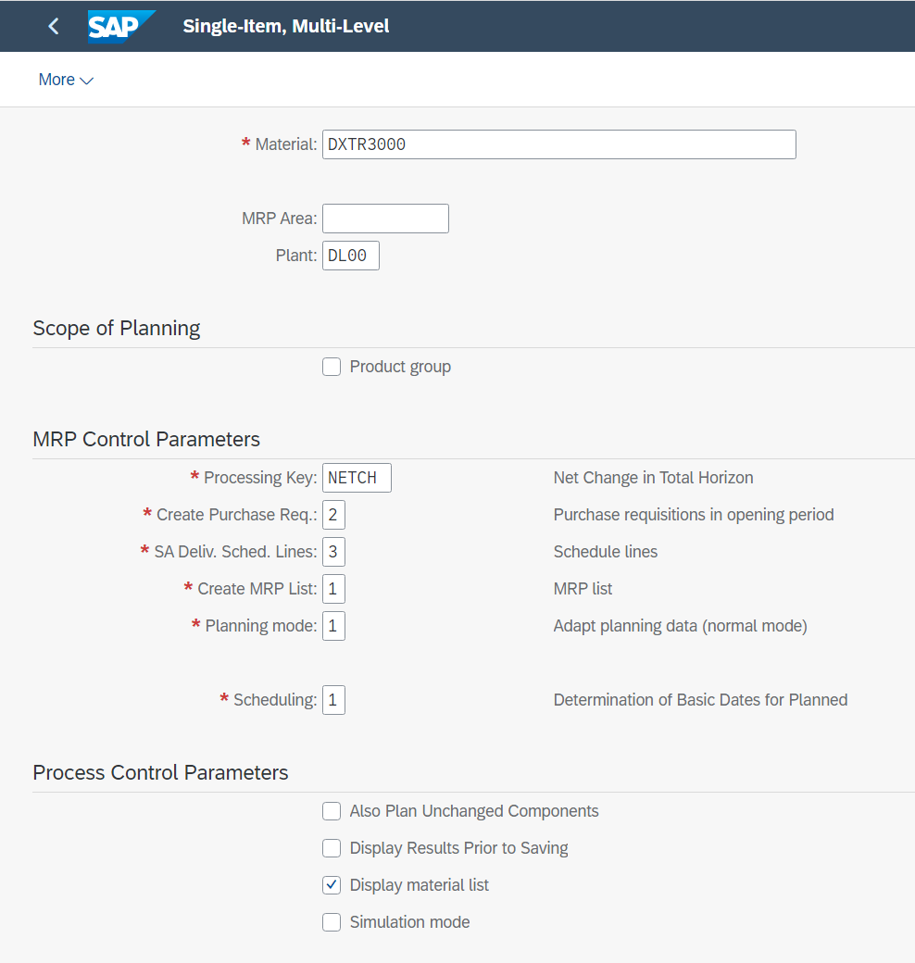
Press Enter. A warning message will appear asking you to check input parameters. Press Enter to confirm and bypass the warning message.
Note In MRP, a net requirements calculation is executed in the planning run to determine whether a material shortage exists for a certain material. In addition, stock and fixed receipts that currently exist (for example, purchase orders, production orders, fixed purchase requisitions and planned orders) are compared with the safety stock and requirements. The result of this comparison is the quantity available for planning.
If the quantity available for planning is lower than zero, a material shortage exists. MRP reacts to material shortages by creating new procurement proposals (purchase requisitions and planned orders). The suggested procurement quantity results from the lot-sizing procedure that is set in the material master.
As soon as the planning run is completed, a result overview is displayed. Check the planning details of the result overview.
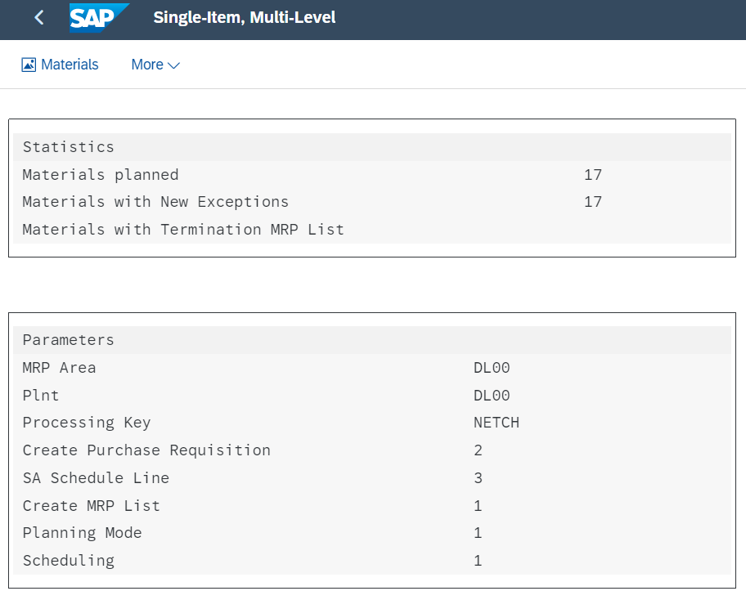
Scroll down further, there you will see a detailed listing of all materials considered.
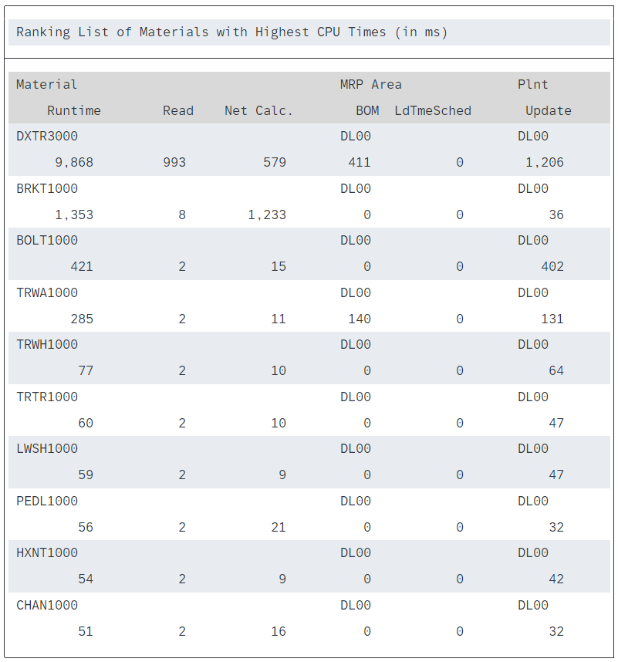
Click to return to the SAP Fiori Launchpad.

 | Step 8: Review Stock/Requirements List
Task Review the Stock/Requirements List.  Short Description Review the Stock/Requirements List for your deluxe touring bike.  Name (Position) Lars Iseler (Shop Floor Worker 2) |  | Time 10 min
The Stock/Requirements List is a list which dynamically changes whenever a transaction occurs using the given material. Display and review the Stock/Requirements List for all materials of the red deluxe touring bike on hand and the demand that exists against these products. The report shows that there is no stock and therefore nothing is available for use at this time. |  | Stock/Requirements List
To display the stock/requirements list, use the Monitor Stock/Requirements List app in the Production Planning and Execution area. |  | Monitor Stock/Requirements List
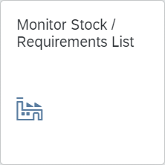
On the Individual access tab, enter Material DXTR3### and Plant DL00. Click on  to display the associated stock/requirements list. |  | DXTR3###  DL00
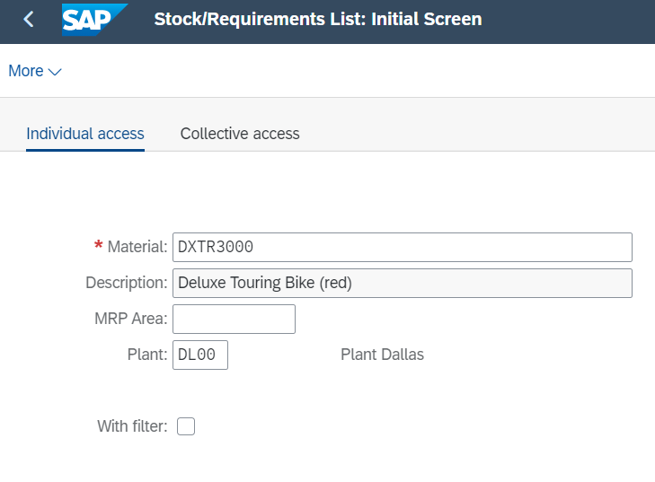
Currently, the system lists all entries as single rows.
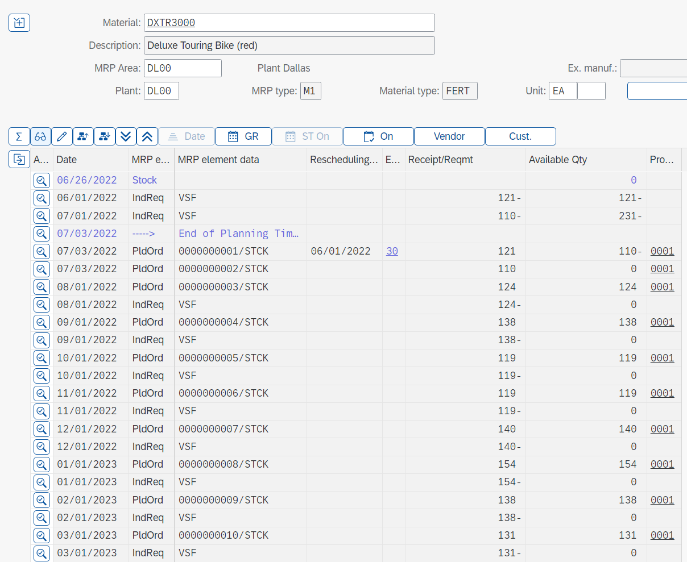
Choose (Switch to Period Totals). This will allow you to see the planned independent requirements, planned receipts, and ATP quantities based on time - days, weeks, or months.
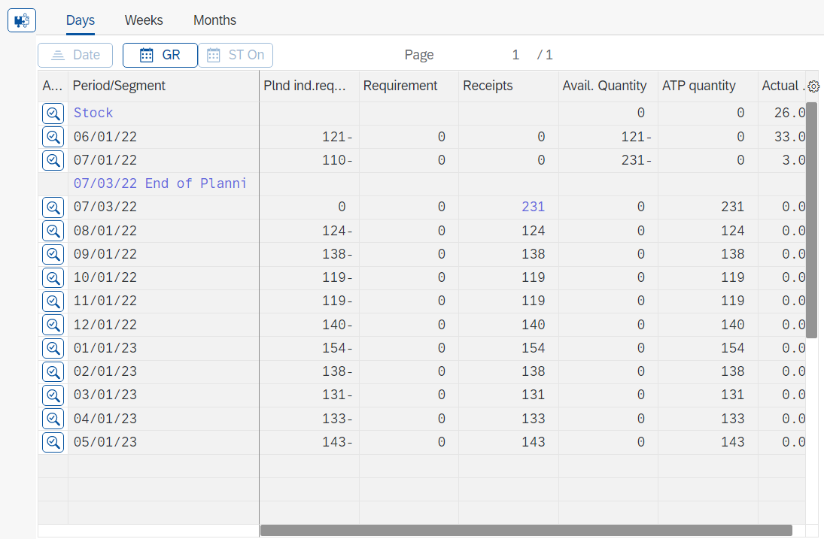
Select to go back to the individual rows.
To view the details of the first planned order (PldOrd), select (Element Details).
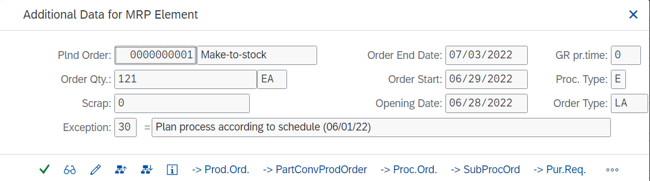
Select to display the pegged requirements.
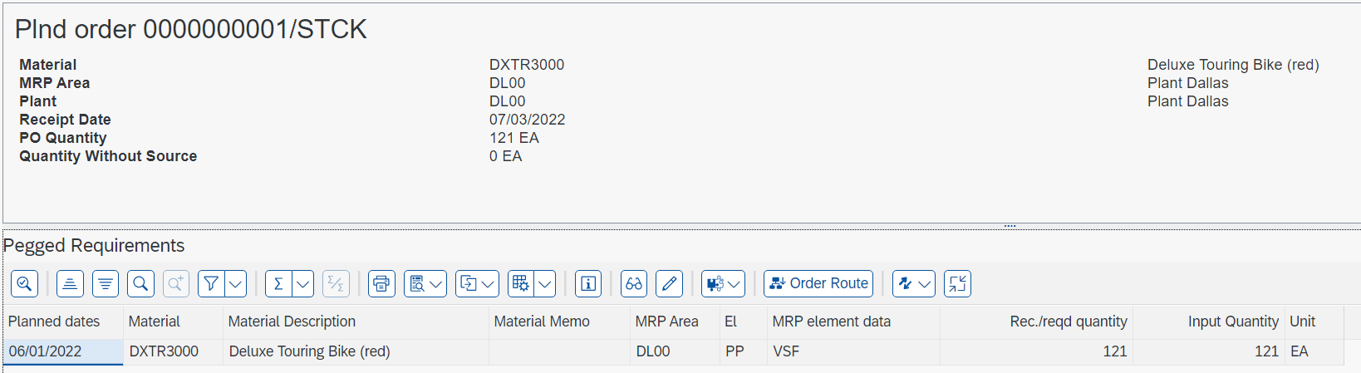
You can see that this planned order is to fulfill our Safety Stock and the first planned independent requirement that was created when we disaggregated our SOP.
Click to return to the SAP Fiori Launchpad.

 | Step 9: Convert Planned Order into Production Order
Task Convert a planned order into a production order.  Short Description Convert a planned order generated in the MPS/MRP run to a production order. The stock requirements list displays the suggested planned orders from the MPS run.  Name (Position) Lars Iseler (Shop Floor Worker 2) |  | Time 10 min
To convert planned orders into production orders, use the SAP Fiori app Monitor Stock / Requirements List in the Production Planning and Execution area. |  | Monitor Stock / Requirements List
Enter Material DXTR3###, Plant DL00, and click on . |  | DXTR3###  DL00
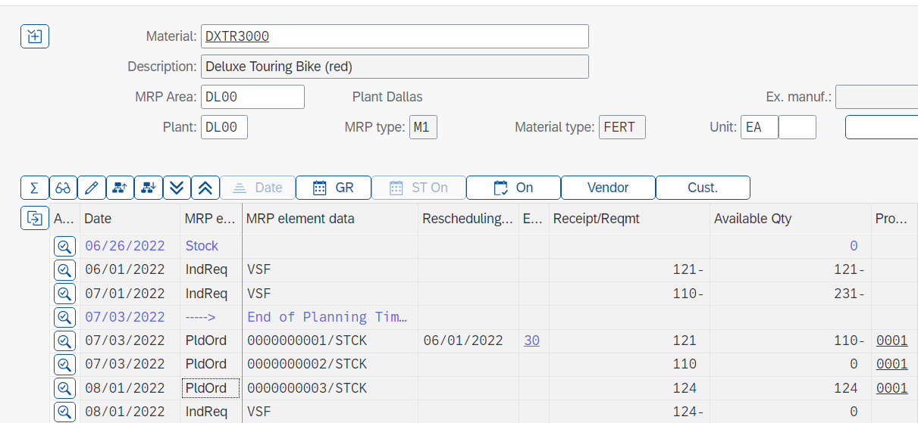
Choose at the beginning of the third planned order. A popup opens with details about the order.
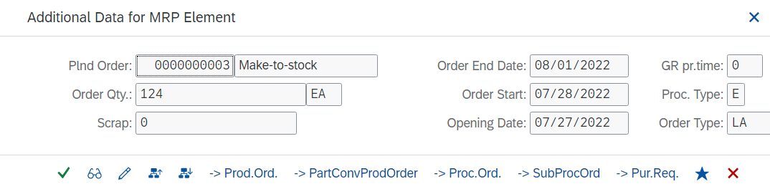
The planned order should now be converted into a production order. To do this, press . The system creates a temporary production order, identified by the generic order number, and releases it automatically.
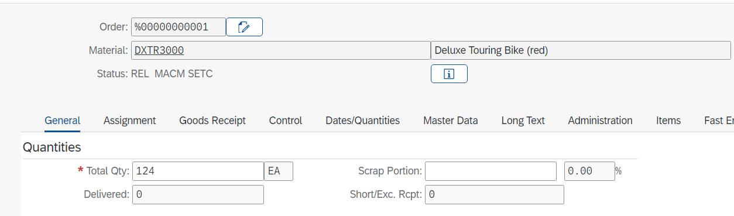
Note At this point, please note down the total quantity in your production order. You will need it later when confirming your order. |  | Total quantity  ___________________
Determine the status of your order by clicking on .
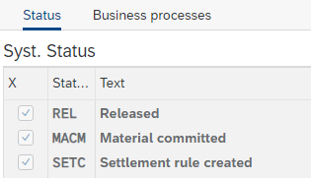
Note When you converted the planned order to a production order, scheduling took place, an availability check was automatically carried out and a reservation was placed on the materials specified within the bill of materials.
Click on , to go back to the Production order Create: Header screen and save your production order with .
Note When you save the production order the system will automatically calculate the planned costs for the production order.
The system assigns a unique number to the production order. Please make a note of the production order number.
Production order number

___________________
You will automatically return to the requirements/inventory list. Select to refresh the list. The planned order PldOrd that you had selected is now available as a production order PrdOrd.
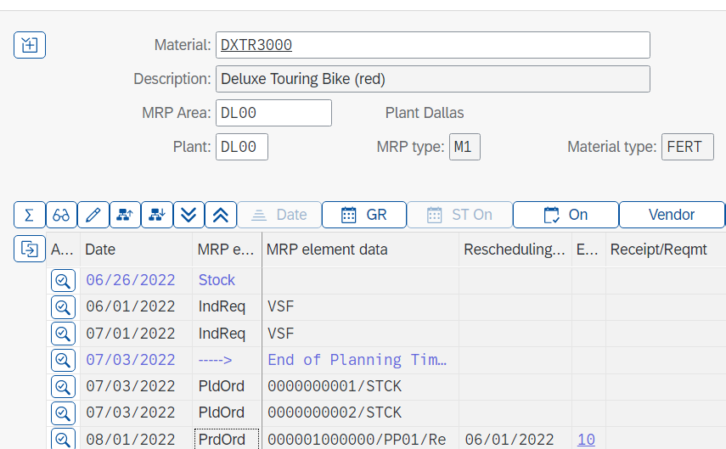
Click to return to the SAP Fiori Launchpad.

 | Step 10: Receive Goods in Inventory
Task Receive goods in the Dallas plant.  Short Description Receive enough goods in the Dallas storage locations to start the production process.  Name (Position) Susanne Castro (Goods Receipt Clerk) |  | Time 10 min
Usually, at this point the purchasing department in Dallas would take over and procure enough raw materials from vendors to fill the inventory so that the production process can be initiated. In this case study, we are bypassing this procurement process (this process is explained in the MM unit in detail). Because the inventory for all DXTR3### components is empty, we will assume that we find 500 pieces each in the storage location. |  | Goods receipt
To receive goods in the inventory, use the app Post Goods Receipt without Reference in the Production Planning and Execution area. |  | Post Goods Receipt without Reference
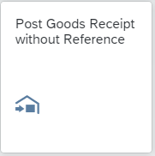
The document and posting date are already defaulted with the current date and can thus be transferred.
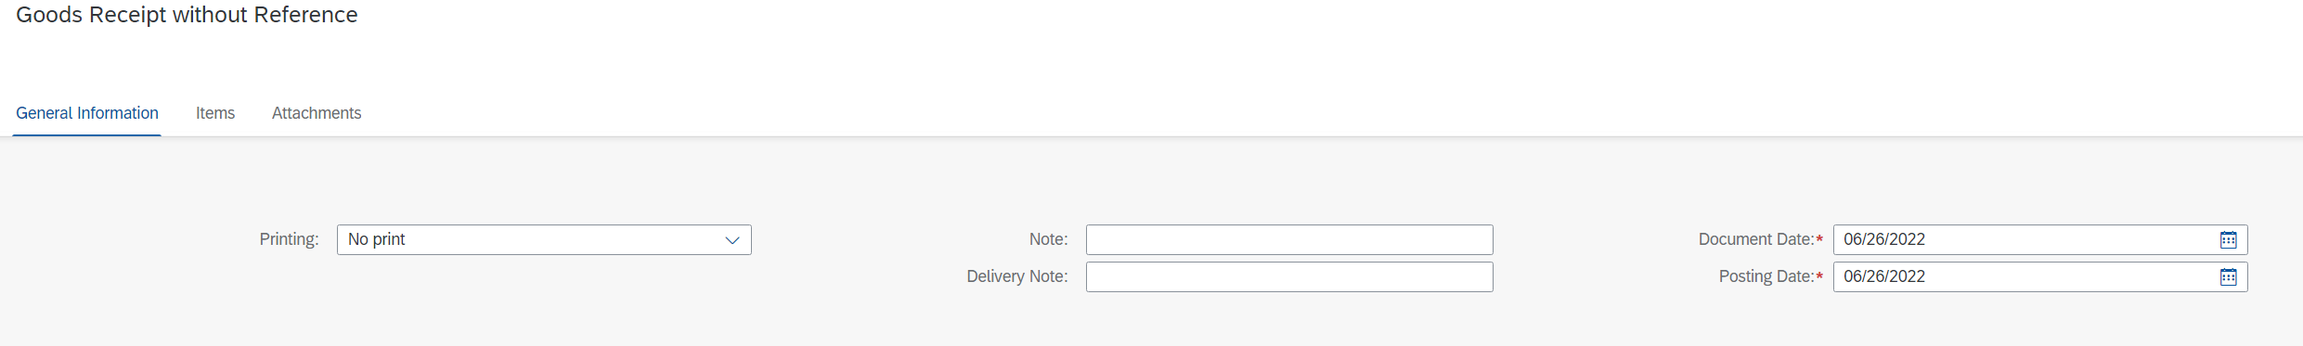
Directly below you will find the Item section. The table there is ready for input and offers item 01 in advance. |  | Items
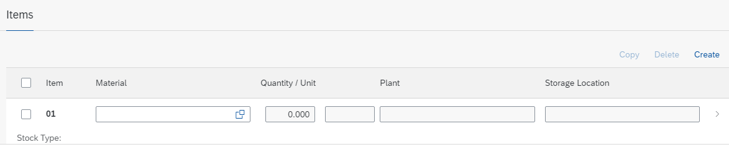
Click on the line of item 01, you will switch to a separate input window.
Enter your Material TRWA1### and press Enter.  Now you can enter the Quantity 500 with Unit EA.  Next, choose Plant DL00. When choosing the Storage Location your storage for semi-finished goods is will be proposed. You can check the status directly in the selection screen. |  | TRWA1###  500  EA  DL00  SF00
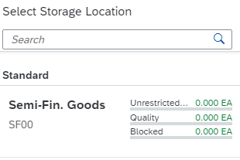
Choose the Storage Location SF00. The Stock Type is automatically set to Unrestricted-Use, and the Special Stocks is None. |  | Unrestricted-Use  None
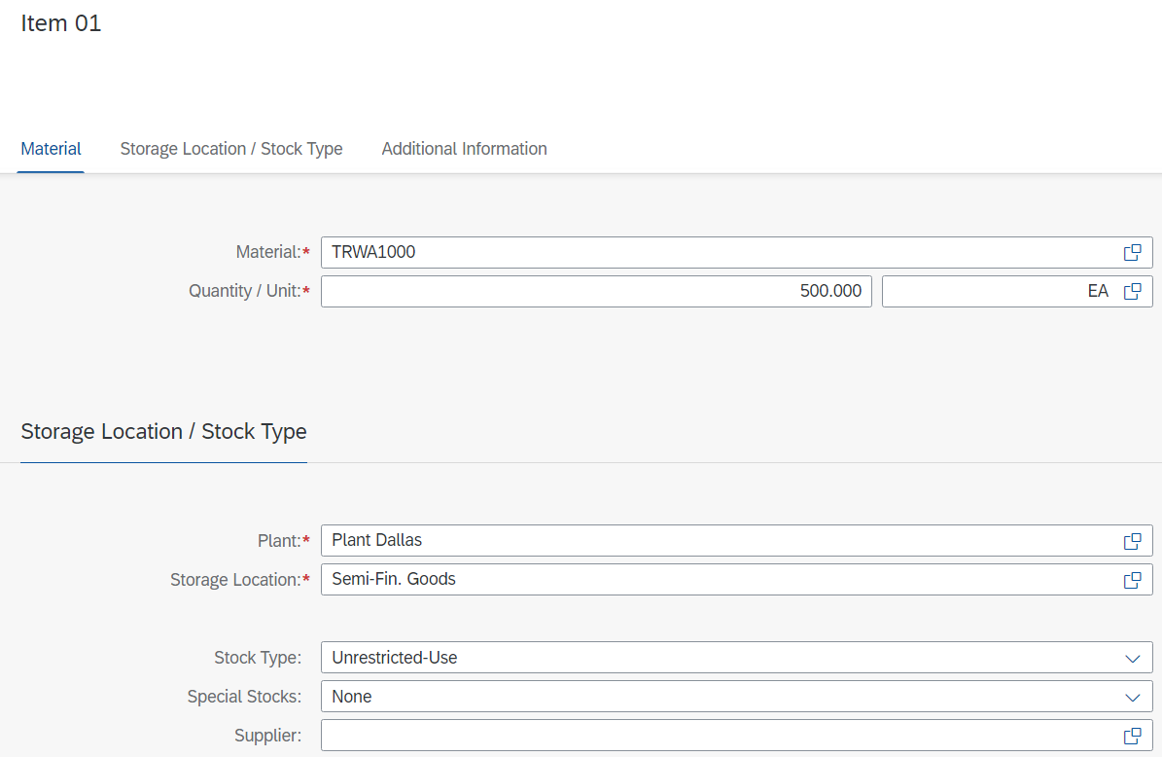
Click on to accept your entries and, at the same time, to be able to specify a new item. The system confirms the transfer of the item.
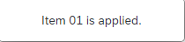
Now repeat the procedure for the other components of the bike DXTR3###.
 |  | TRFR3###  DGAM1###  TRSK1###  TRHB1###  PEDL1###  CHAN1###  BRKT1###  WDOC1###  PCKG1###
  Material | Quantity | Unit | Plant | SLoc
  TRFR3### (Touring-Frame-Red) | 500 | EA | DL00 | RM00
  DGAM1### (Derailleur Gear Assembly) | 500 | EA | DL00 | RM00
  TRSK1### (Touring Seat Kit) | 500 | EA | DL00 | RM00
  TRHB1### (Touring Handlebar) | 500 | EA | DL00 | RM00
  PEDL1### (Pedal Assembly) | 500 | EA | DL00 | RM00
  CHAN1### (Chain) | 500 | EA | DL00 | RM00
  BRKT1### (Brake Kit) | 500 | EA | DL00 | RM00
  WDOC1### (Warranty Document) | 500 | EA | DL00 | RM00
  PCKG1### (Packaging) | 500 | EA | DL00 | RM00
As soon as you create the last item, confirm it with to automatically return to the goods receipt posting. There you will see all created items.
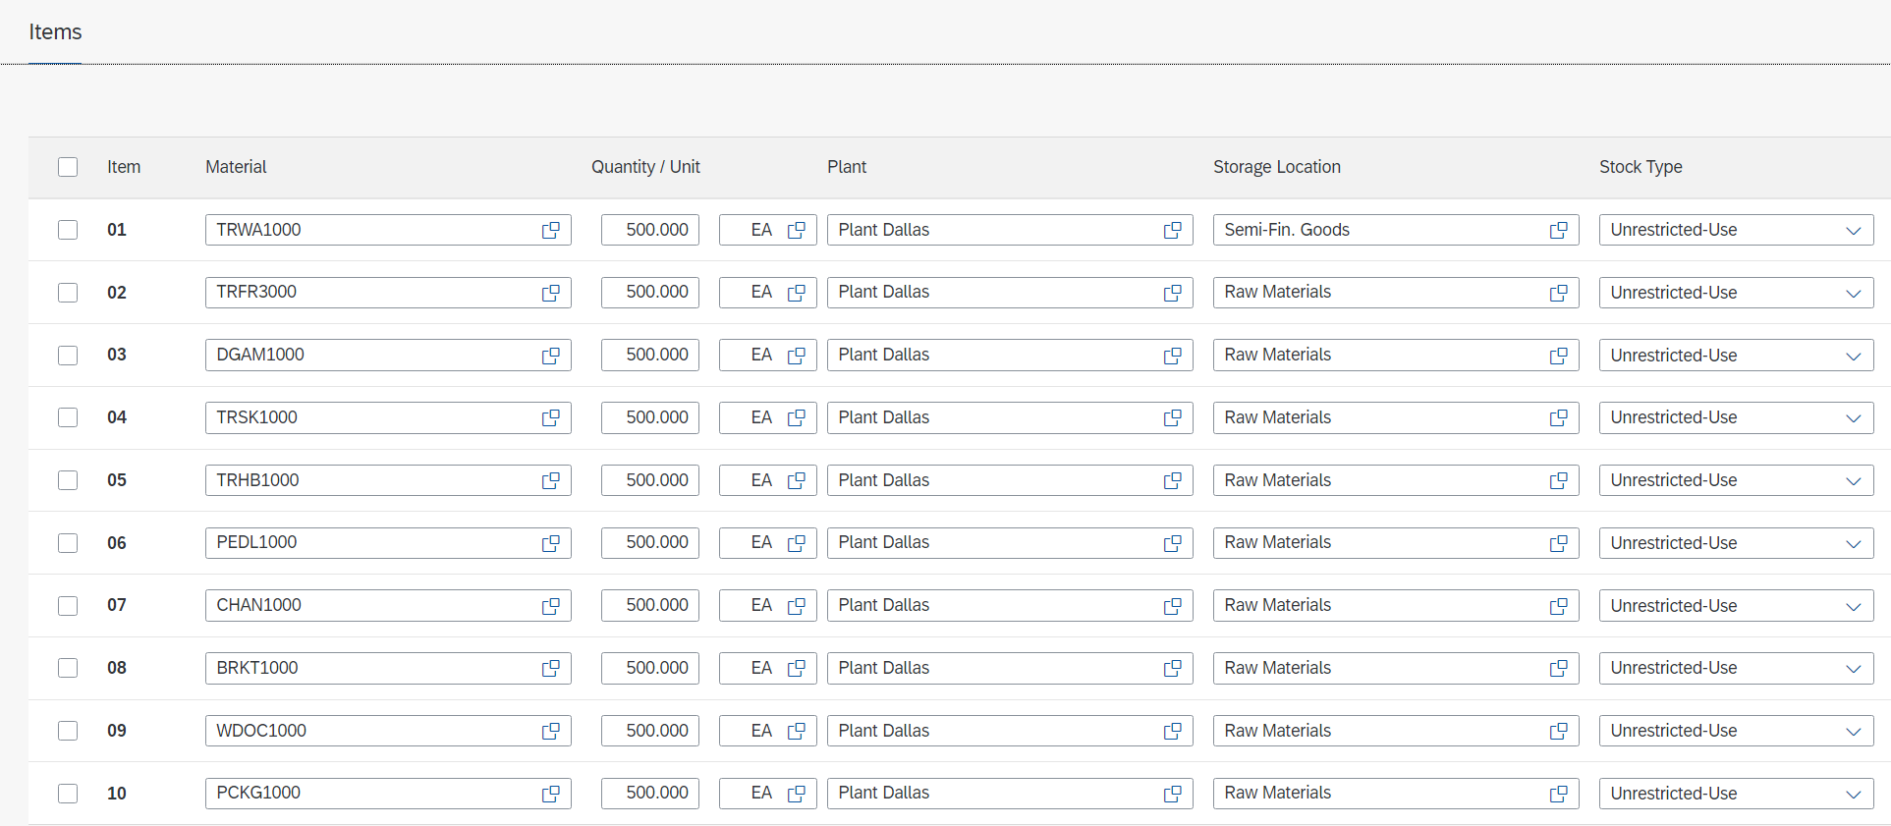
Note If you have forgotten an item, you can add further items by clicking on . Furthermore, you can also correct entries if necessary.
Secure your goods receipt with . The SAP system will assign a unique number to the goods receipt and issue an associated message.
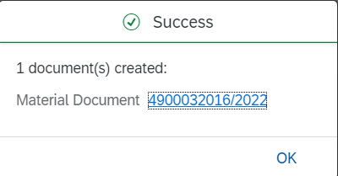 |  | Material Document Number  ___________________
Confirm the success message with .
Click to return to the SAP Fiori Launchpad.

 | Step 11: Issue Goods to Production Order
Task Issue goods to a production order.  Short Description Now that all necessary components are on stock issue them to your production order in precise quantity.  Name (Position) Sanjay Datar (Warehouse Employee) |  | Time 10 min
The goods issue process is fully defined in the production order, BOM, and routing. The quantities and the materials are reserved for this specific production order, they will be withdrawn with reference to the order number and will be used to assign actual costs to the production order for managerial accounting purposes.
To issue goods to a production order, use the app Post Goods Movement in the Production Planning and Execution area. |  | Post Goods Movement
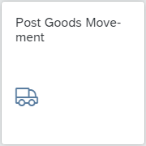
Make sure that Goods Issue and Order are selected in the drop-down menus.
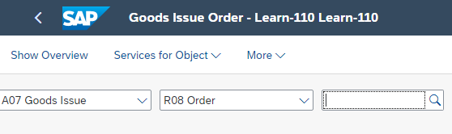
The Document Date as well as the Posting Date should be already set to the current date. The Movement Type should be set to 261 (GI for order).
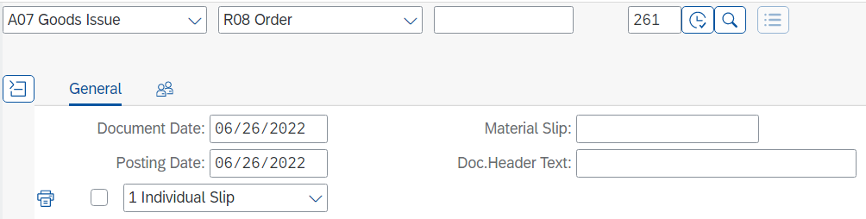
Enter your noted production order number.
Alternatively, click the value help icon in the order field. In the Order Number popup (1), use the icon on the far right to display a list of all tabs. Select the tab Process Orders using the Info System. On this tab, enter your material DXTR3### in the Material field and click . Select your order and accept it with . |  | Process Orders using the Info System  DXTR3###
Once you have found or entered your production order number, press to load the order details.
Note Goods issues posting for the required components is another milestone in the production order process. The following functions are performed when a GI for the components of the production order is posted:
- Storage-location-specific update of the stock and consumption fields
- Reduction of the reservation (for planned withdrawal)
- Update of costs for unplanned withdrawals
- Determination of actual costs (valuation) and order update
- Consumption update
- Generation of material and accounting documents (FI and CO documents)
- Creation of material document.
- Creation of accounting document
- Creation of controlling document
- Printing of GI document
The goods issues posting is controlled through a movement type (261), to which each posting refers. This can take place manually or automatically.
An itemized list will appear. It lists all the materials and their respective quantities that need to be issued to your order. You need to tell the system what Storage Location the materials should be withdrawn from. For the Touring Aluminum Wheel Assembly (TRWA1###), enter SF00 (Semi-finished goods) and for all other materials RM00 (Raw materials) in the SLoc fields. Before pressing Enter compare your screen with the one shown below. Notice that your quantity could be different. |  | SF00  RM00
Flag each item with OK. If you can't flag the first item please close the detail view with a click on  unter the line item list. |  | OK
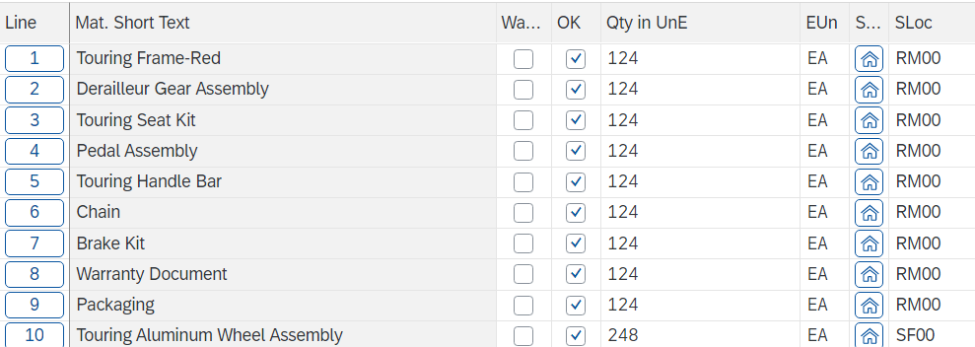
Click on and record the material document number.
Material Document Number

___________________
Click to return to the SAP Fiori Launchpad.

 | Step 12: Review Production Order Status
Task Review the production order status.  Short Description Review the current production order with respect to the status of the order.  Name (Position) Michael Brauer (Shop Floor Worker 4) |  | Time 10 min
To display the production order, use the app Manage Production Orders in the Production Planning and Execution area. |  | Manage Production Orders - Orders
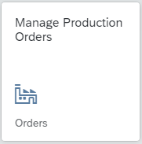
When you open the app for the first time, you will see a welcome message telling you to select an area of responsibility. Confirm this with , another popup will appear.
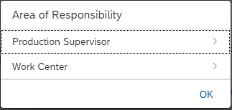
Choose Production Supervisor. No Plant is currently assigned. Click on an choose the Plant Dallas. Confirm your selection with .
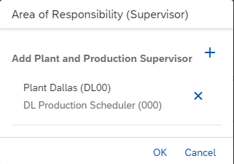
Confirm your selection with now click on Work Center.
Click on again and choose the Work Center DL Assembly (ASSY1000), DL Inspection (INSP1000) and DL Packaging (PACK1000) from your Pland Dallas and click on .
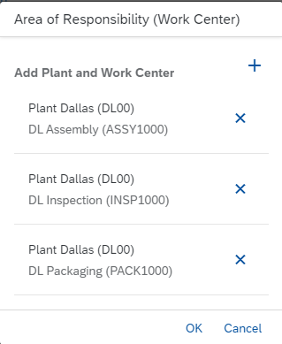
Confirm your selection with , and press to leave the selection or the area of Responsibility.
You will receive an overview of all existing orders. Depending on the progress of your course, there may be several production orders with different processing statuses.
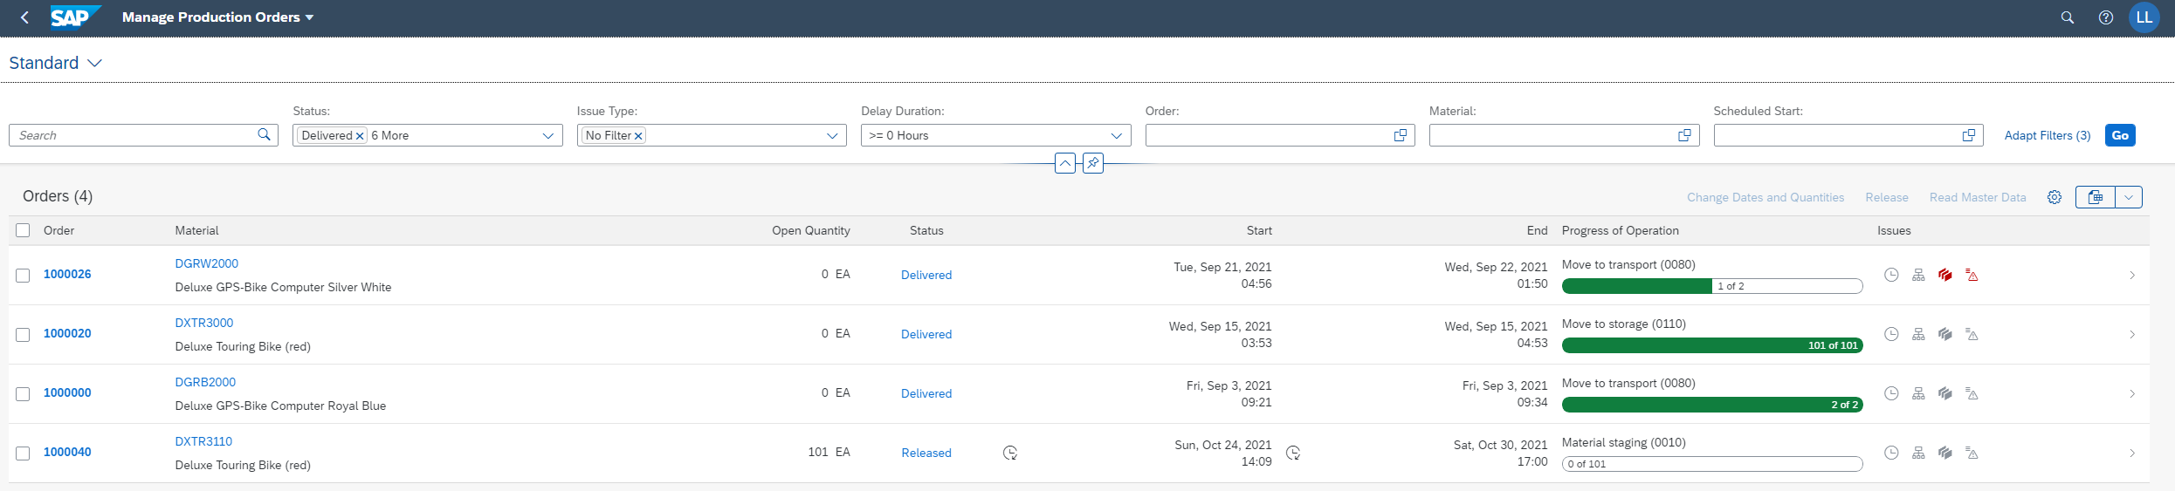
In the field Material enter your material DXTR3### and choose to display your order. |  | DXTR3###
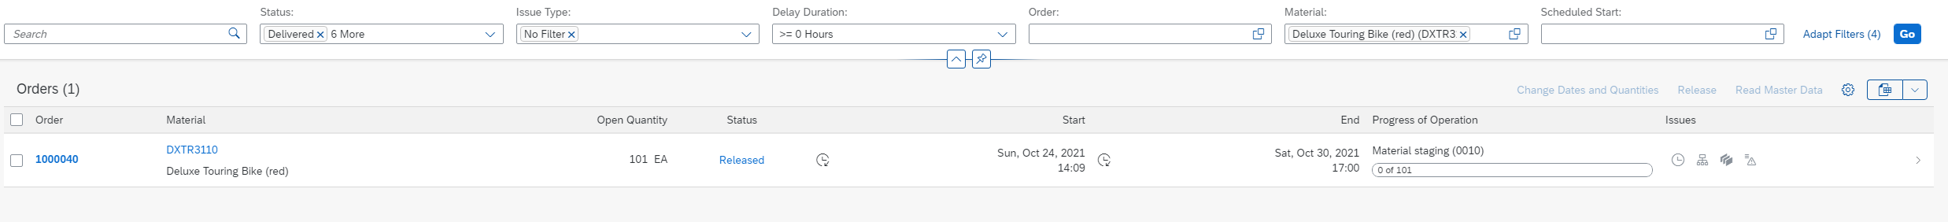
The tabular overview already provides you with various information about your order, such as the current status and the current processing status.
For further information select the entry. You will be forwarded to the details of the production order.
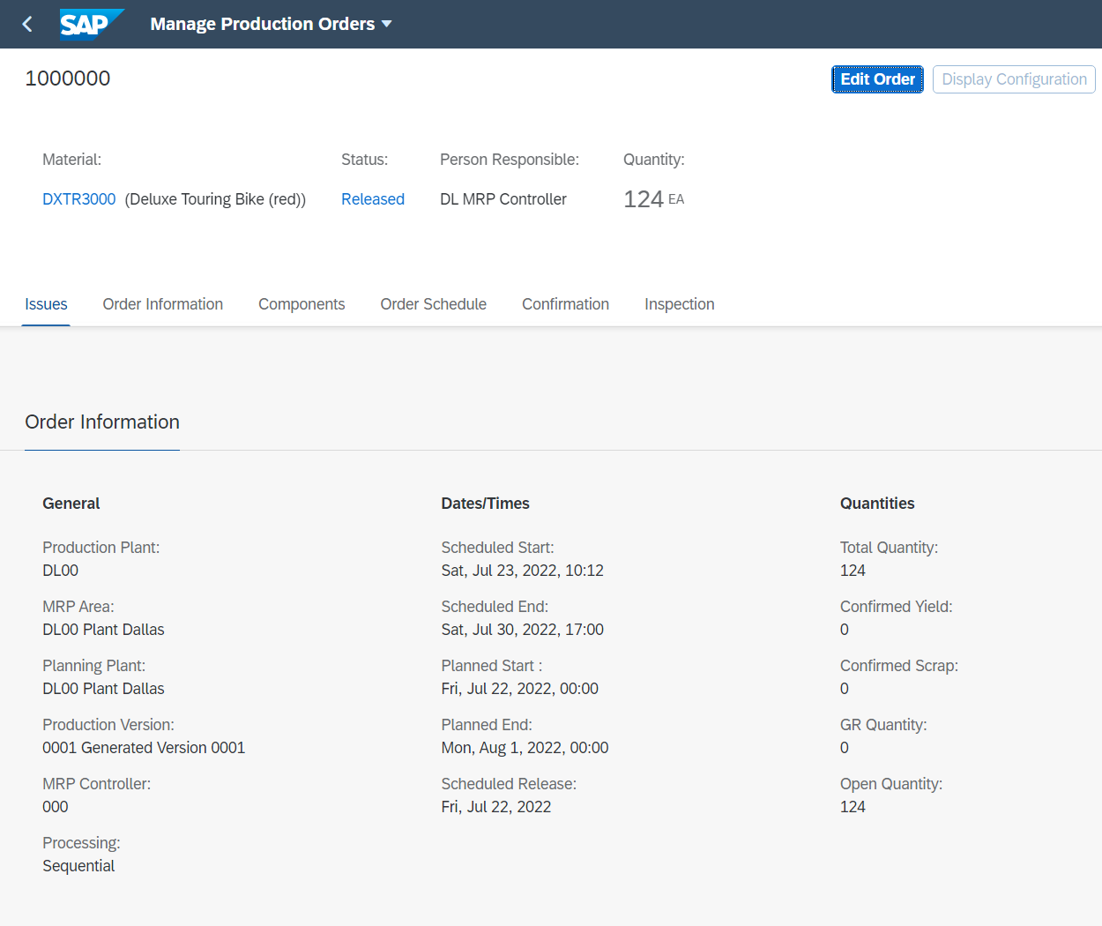
Click on the status for more information. You can see that your production order is precosted and a settlement rule has been created.
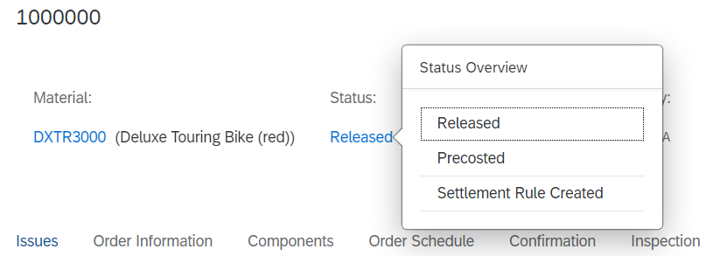
Now click on the Components tab. The screen scrolls to the corresponding position. |  | Components
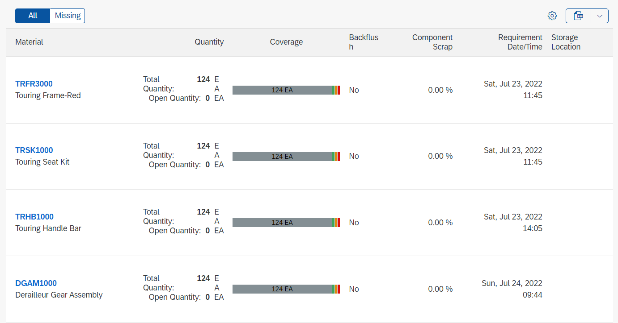
In the last task, you posted the goods issue for the production order. In the production order, you now see that there are no more open quantities for this order.
Click to return to the SAP Fiori Launchpad.

 | Step 13: Confirm Production Completion
Task Confirm production order completion.  Short Description Confirm completion for your production order.  Name (Position) Michael Brauer (Shop Floor Worker 4) |  | Time 10 min
When the assembly has been completed for the current production order, we need to confirm that certain procedures and activities have been completed and record the quantity of the finished product that has been manufactured. |  | Production completion
To confirm production completion, use the app Enter Production order Confirmation in the Production Planning and Execution area. |  | Enter Production order Confirmation
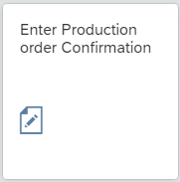
Enter your production order number and click on or Enter. |  | Production order number
Alternatively, use the Input-Help-Symbol and switch in the popup with to the tab production orders by material and routing, enter your material number DXTR3## there and search for your order.
Check if Final Confirmation and Clear Open Reserv. is already checked in the Confirmation Type section. |  | Final Confirm.  Clear Reservation  Amount
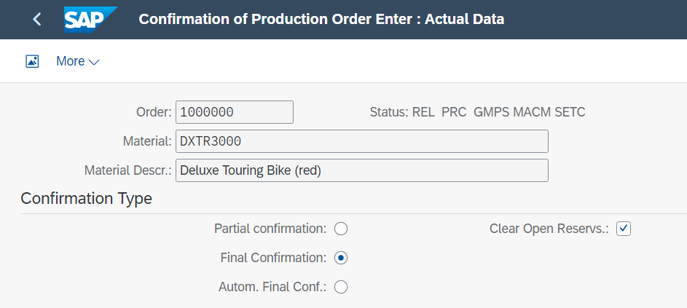
Furthermore, in the Actual Data tab, the quantity of bicycles that you should produce for this order should already be entered in the Yield Quantity field. Change the Start Execution to 1 hour earlier than the pre-set time. |  | 1 hour earlier
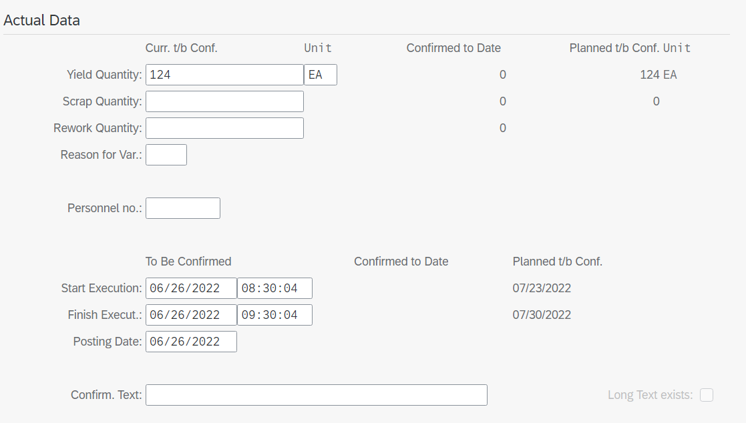
Save your entries with . You will get a confirmation from the system.
Note When the confirmation is saved, labor costs for the order are calculated automatically. The quantity yield also establishes the parameters for the goods receipt into Inventory.
Click to return to the SAP Fiori Launchpad.

 | Step 14: Review Production Order Status
Task Review the production order status.  Short Description Review the current production order with respect to the status of the order.  Name (Position) Michael Brauer (Shop Floor Worker 4) |  | Zeit 10 Min.
To display the production order, use the app Manage Production Orders in the Production Planning and Execution area. |  | Manage Production Orders
In the field Material enter your material DXTR3### and choose to display your order. |  | DXTR3###
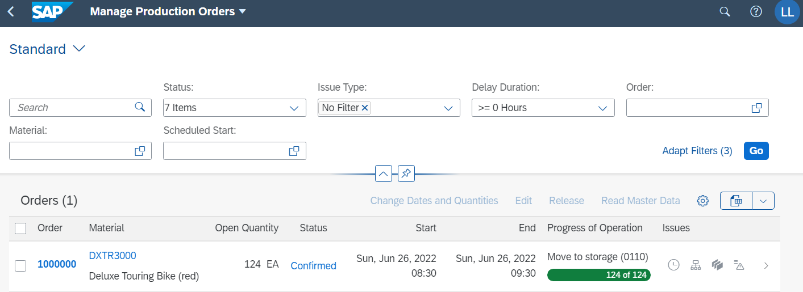
As you can see, the status of your production order has changed from Released to Confirmed. Furthermore, the processing status is now at Move to storage.
For more information, select the entry, you will be redirected to the details of the production order. Click on the Confirmation tab to go to the related area. |  | Confirmation
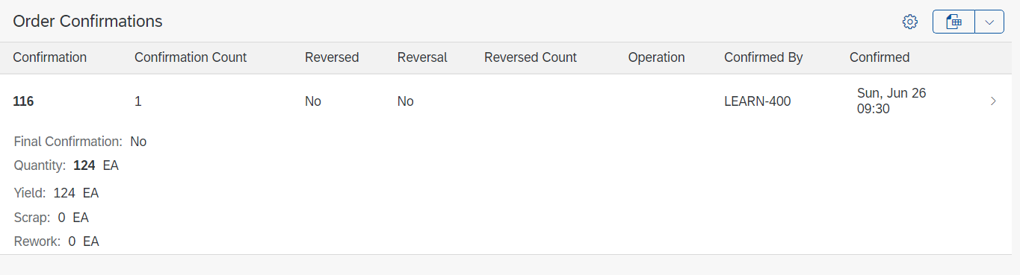
An order confirmation is now available. You can see that the complete quantity of your production order has been confirmed and that there is no scrap.
After the confirmation, the goods receipt now needs to take place to complete the order.
Click to return to the SAP Fiori Launchpad.

 | Step 15: Receive Goods from Production Order
Task Post a goods receipt from production order.  Short Description Post a goods receipt from your production order.  Name (Position) Susanne Castro (Goods Receipt Clerk) |  | Time 15 min
Receive the completed products into finished goods inventory. Check the quantity proposed against the quantity specified in the production order and the quantity specified during confirmation. If there are any discrepancies, the system will decide if an error or warning message should be generated, depending upon the deviation identified. |  | Goods receipt
To post the goods receipt, use the app Post goods receipt for production order. |  | Post goods receipt for production order
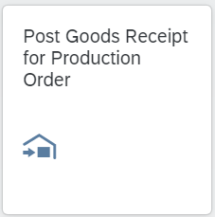
Enter your noted production order and press Enter. |  | Production oder
As an alternative use the Input-Help-Search and enter your material DXTR3### and click . Then select your production order from the result list. |  | DXTR3###
Your production order is loaded and displayed.
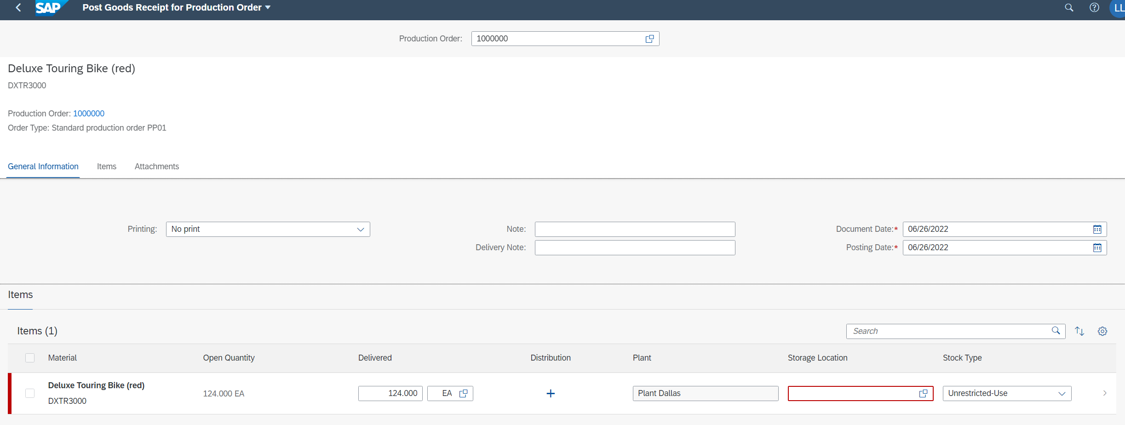
Add the storage location FG00 for end products, all other settings can be accepted.
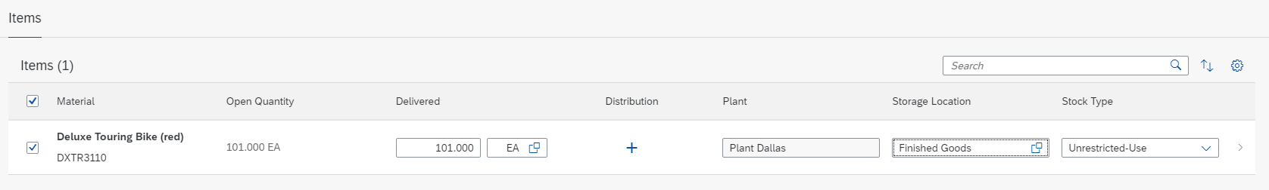
Save your goods receipt with . The SAP system will assign a unique number to the goods receipt and issue a corresponding message.
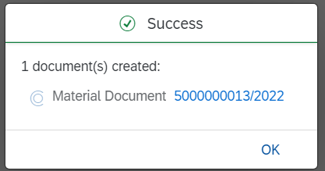 |  | Material Document Number  __________________
Furthermore, this updates the current value of the material produced to the production order.
Confirm the successmessage with .
Click to return to the SAP Fiori Launchpad.

 | Step 16: Review Costs Assigned to Production Order
Task View the corresponding costs assigned to your production order.  Description Review all costs associated with your production order.  Name (Position) Jamie Shamblin (Controller) |  | Zeit 5 Min.
To view the cost of a manufacturing job, use the Production Cost Analysis app. |  | Production Cost Analysis
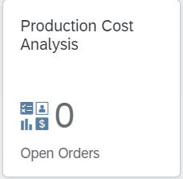
In the Material field enter DXTR3### and change the Order Status from Open to Closed |  | DXTR3###  Closed
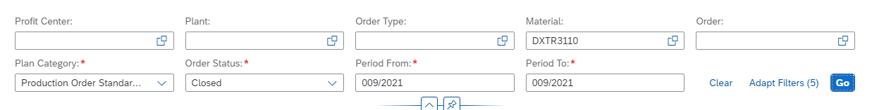
Click on to start the search. Your recently completed production order will be displayed.
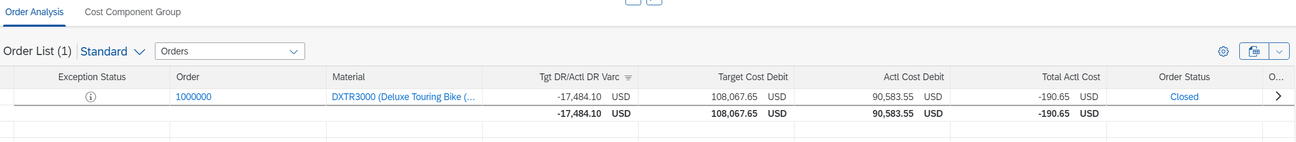
This overview lists the summed target and actual costs and shows any variances. Click on at the end of the entry to open the cost details.
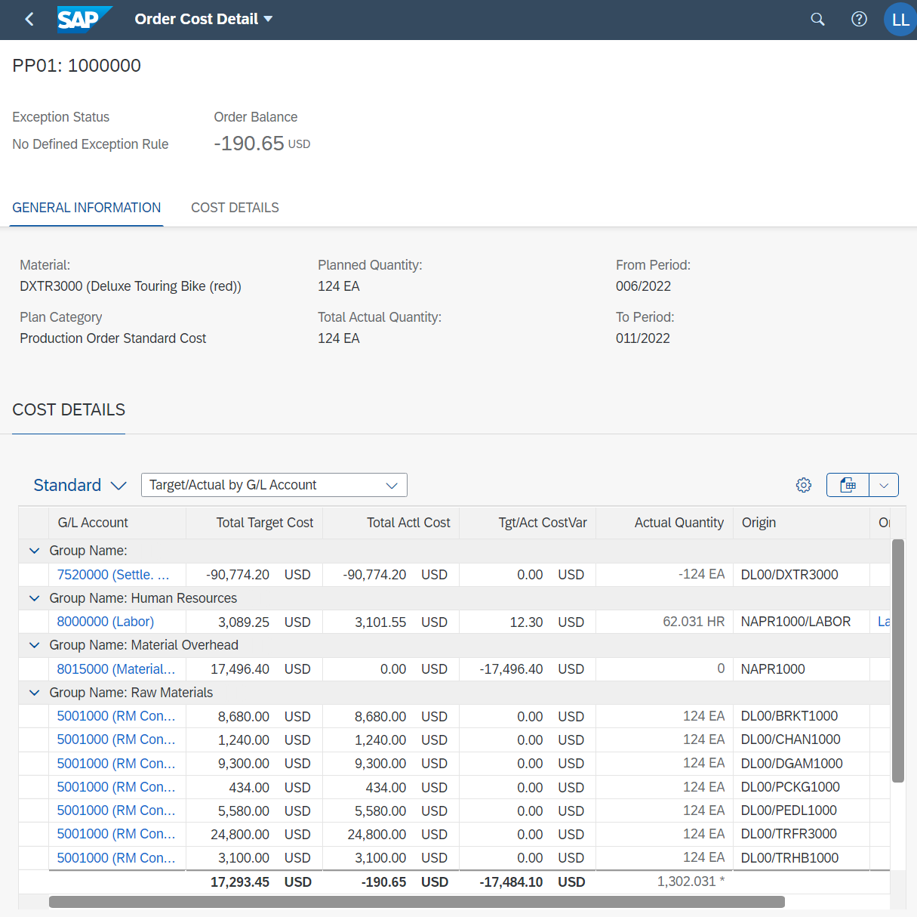
Now that the finished products have been received in the Inventory, the Manufacturing Output Settlement Variance has been added. How is this figure calculated by the system?

Click to return to the SAP Fiori Launchpad.

 | Step 17: Settle Costs of Production Order
Task Settle costs of your production order.  Short Description Settle the costs of your production order. The costs are temporarily captured in the production order and they need to be assigned to an appropriate cost object. Compare the actual costs to the planned costs to identify any deviations or potential problems in this regard.  Name (Position) Jamie Shamblin (Cost Accountant) |  | Time 20 min
To settle costs of a production order, use the app Run Actual Settlement - Order - Single in the Production Planning and Execution area. |  | Run Actual Settlement - Order - Single
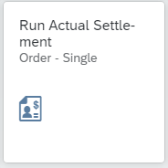
If you have to input the Controlling Area, enter NA00, and click on . |  | NA00
Enter your production order number, alternatively search for it with your material DXTR3### in the Input-Help. In the Parameters section enter Settlement- and posting period as current month (e.g., 006 for June). Enter as Fiscal Year the current year. Make Sure that Test Run is checked in the Processing Options section. |  | Order number  current month  current year  Test Run
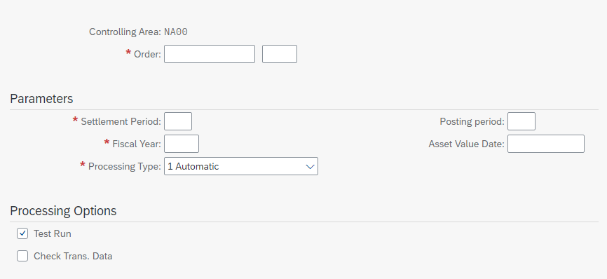
Click on to proceed. Confirm any occurring pop-ups with enter. You enter the screen Actual Settlement: Oder Basic list.
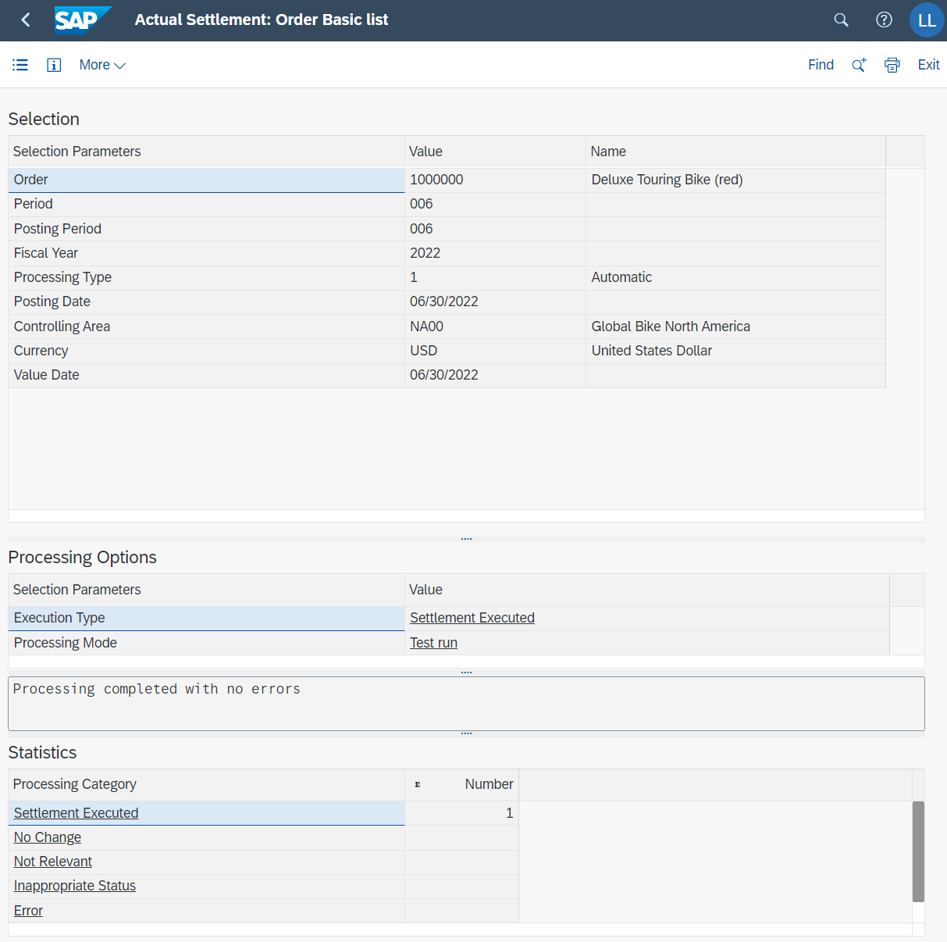
Click on to open the detail lists.
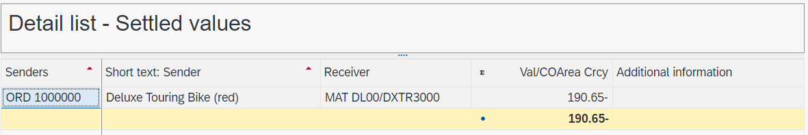
From the Menu bar choose:  More ► Environment ► Report |  | Menu Bar
The Select Report pop-up will appear.
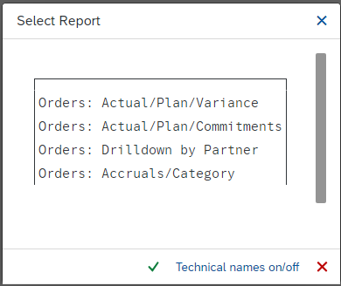
Click on Actual/Plan/Variance and confirm your selection with . A corresponding report group is generated and displayed. |  | Actual/Plan/Variance
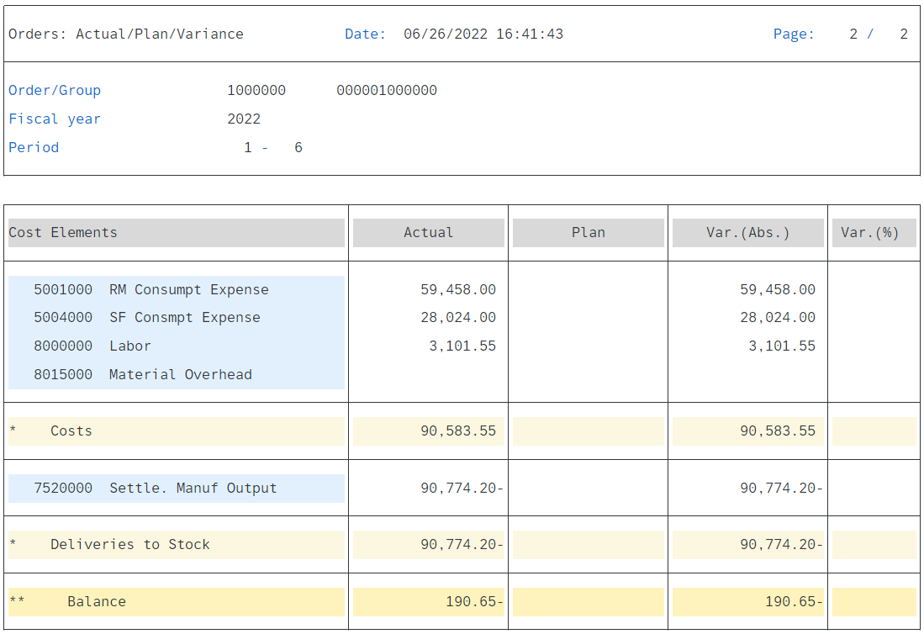
The test run is now complete and the actual settlement should now be performed.
Click on to go back. Confirm the Message to leave the report with . Afterwards press two times to get back to the entry screen.
Deselect Test Run and again click on . In contrast to the previous run, you can now see in the Processing Options area that this was an update run that was completed with no errors. |  | Testlauf
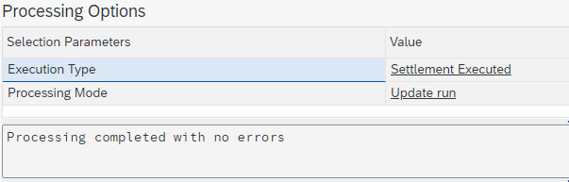
Open the report Actual/Plan/Variance again by clicking on first and then use the menu bar path More ► Environment ► Report and select the option Actual/Plan/Variance. |  | Actual/Plan/Variance
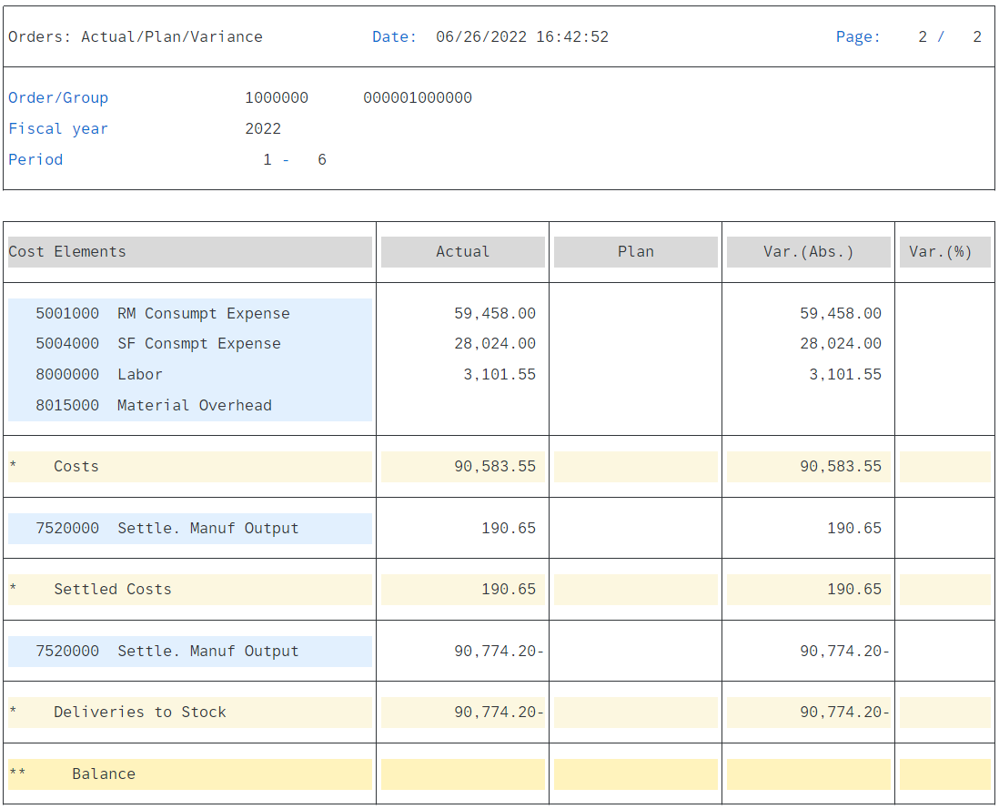
You can see that the costs have now been settled.
Click to return to the SAP Fiori Launchpad.

 | PP Challenge
Learning Objective Understand and perform an integrated manufacturing process. |  | Time 60 min
Motivation After you have successfully worked through the Production Planning and Execution case study you should be able to solve the following challenge on your own.
Scenario In this challenge you should create sales and operations plan (SOP) for the product group (product family) Mountain bikes. Take into consideration that the materials of the product group have to be assigned to the strategy group. Therefore, enter manually the following sales figures:
Period | Sales (volume)
Current month + 2 | 150
Current month + 3 | 175
Current month + 4 | 200
Current month + 5 | 85
Current month + 6 | 90
Current month + 7 | 115
In addition, you must post the correct goods for Material ORMN1### in the storage location in order to be able to produce and settle costs afterwards.
Task Information Since this task is based on the Production Planning and Execution case study you can use it as guidance. However, it is recommended that you solve it without any help in order to test your acquired knowledge.

